Annual Report – 2019-2020
CONTENTS/PROJECTS

Sl.No. | Name of the Project
1 | Brief Description about the Projects and Programmes
2 | Deformity Preventive Medical Research (DPMR) – Netherlands – Fontilles
3 | CCI (children care India) - Aipe international, Canada  Children Education  Grant in Aid (Livelihood)  Anganwadi school
4 | Open shelter
5 | URH (urban residential hostel)
6 | BASIX India – FPO
7 | ZBNF – Awareness activities programmes
8 | Crèche centers
9 | National Child Labour Project (NCLP)
10 | Block Level sports – Nehru Yuva Kendra
11 | Usha – Skill Development Programme
12 | Covid – 19 – Relief Activities.
13 | TDH (Terra des homes) – Zermany / Navajeean Balabhavan / samata
14 | General programme  Health awareness programmes  Sanitation awareness programme  VSS trainings

P. VENUGOPALA RAO
Secretary/Executive Director.
NEED.

ANNUAL REPORT - 2019-2020

Brief Description about the projects implementing during the year of 2019-2020:

NEED is the Registered voluntary organisation, working for the upliftment of the poor, down trodden community and poorest of the poor, especially for the development of Tribal people in Vizianagaram District, During the year of 2018-2019 NEED has been continuously implementing Deformity Preventive medical research (DPMR) Project, CCI (Children care India) with the support of Aipe international, Canada in this area we are supporting Children education, providing Micro credit and organizing Anganwadi schools, and we have created awareness on Migrant family children with the support of TDH (Terra des homes), and organizing Open shelter with the support of Department of Juvenile welfare, Correction services & welfare of street children, Govt. of Andhra Pradesh, in Vizianagaram we are implementing Urban Residential hostel with the support of SSA, and with the support of BASICS we are implementing Farmer producer organizations/companies at Vizianagaram and Visakhapatnam and Prakasam districts, and we have organized Health awareness, Sanitation awareness programmes in Pachipenta mandals and also we have provided VSS training programmes to VSS members at our Vizianagaram district with the support of forest department. These are the main activities during the year of 2019-2020.

DEFORMITY PREVENTIVE MEDICAL RESEARCH (DPMR)

1. Profile of the Project Area:

To strengthen the services of OP & IP of Chilakalapalli project as well as support the detection of new cases and strengthen the DPMR services in the field, Fontilles has established a DPMR Field Unit, with headquarters at Chilakalapalli. A leprosy-trained and experienced paramedical worker is placed in this unit, after giving training for one week at Chilakalapalli in leprosy, DPMR and specific documentation procedures. The PMW started field work from 16th August 18.

The project area comprises of 6 PHCs which are still endemic for leprosy. The project aims to coordinate with the ASHA/health staff and strengthen the referral services to PHCs in the project area, facilitate new case detection in early stages and improve field-based DPMR services. Cases with Reaction/Neuritis, complicated ulcers and those in need of protective foot-wear are referred to Fontilles Referral centre, Chilakalapalli. Disability care camps are also conducted along with GH staff, ASHAs & ANMs to enable the leprosy affected persons to adopt self-care practices for disability care. The project PMW also participates in the LCDC programme in case validation of suspected cases

Brief summary of activities & achievements- 2019

S.No | Activity
 | No. of PHCs visited | 6
1 | Follow-up of Disability cases
 | Total GI & GII Cases | 314
 | No. Followed up | 292
 | No. of cases practising self care | 154 (53%)
 | No. of cases demonstrated self care | 128
2 | No. of cases with ulcers
 | No. of simple ulcer cases managed in the field/Healed | 22/23
 | No. referred to Chilakalapalli IP wards | 41
 | No. reported and admitted in Chilakalapalli IP wards | 35
 | No. of ulcers healed | 23
3 | MCR Footwear
 | No. of persons using ordinary footwear | 166
 | No. of measurements taken | 131
 | Number provided | 119
4 | RCS
 | No. Screened and selected for RCS | 1
 | No. Referred for RCS | 1
5 | Govt. Welfare Schemes
 | No. Receiving Disability pension | 74
 | No. Receiving Old age pension | 151
 | No. Receiving Widow Pension | 22
 | No. Receiving AAY (35 Kgs Rice) | 93
6 | Disability Care Camps
 | No. of camps attended ( Monthly Disability camps) | 11
 | No. of Beneficiaries attended | 259
 | No. of patients demonstrated self care | 63

S.No |  | Activity |  |  |  |  |  |  | 6 PHCs
7 |  | Referral Services
a |  | No. of suspected cases Referred to PHCs/RC CLP |  |  |  |  |  |  | 59
b |  | No. of cases reported to PHCs/RC CLP |  |  |  |  |  |  | 56
c |  | No. of new cases confirmed |  |  |  |  |  |  | MB |  | PB |  |  | Tot.
 |  |  |  |  |  |  |  |  | 19 |  | 33 |  |  | 52
 |  | Of 7 c No. of new cases reported with GII disability |  |  |  |  |  |  | 2 |  | 1 |  |  | 3
 |  | Of 7 C No. of Child cases |  |  |  |  |  |  | 1 |  | 6 |  |  | 7
 |  | No. of reaction cases referred to RC CLP |  |  |  |  |  |  | 8 |  | 4 |  |  | 12
8 |  | Follow up of UT cases
 |  | No. of UT cases followed up |  |  |  |  |  |  | 22 |  | 30 |  |  | 52
 |  | No. taking regular treatment |  |  |  |  |  |  | 19 |  | 21 |  |  | 40
 |  | No. of high risk cases among UT cases |  |  |  |  |  |  | 11 |  | 2 |  |  | 13
9 |  | Training
 |  | No. of PHCs Visited |  |  |  |  |  |  | 6
 |  | Number participated |  |  |  |  |  |  | GH staff |  |  |  |  | 240
 |  |  |  |  |  |  |  |  | ASHA |  |  |  |  | 604
10 |  | Surveys
10.1 |  | School Survey
 |  | No. of Schools covered |  |  |  |  |  |  | 46
 |  | Enumeration |  |  |  |  |  |  | 3332
 |  | Examination |  |  |  |  |  |  | 3031
 |  | No. suspected |  |  |  |  |  |  | 2
 |  | No. Con firmed |  |  |  |  |  |  | 1
10.2 |  | Contact Survey
 |  | No. of index cases |  |  |  |  |  |  | 466
 |  | No. of contacts enumerated |  |  |  |  |  |  | 1230
 |  | Examination |  |  |  |  |  |  | 916
 |  | No. of cases suspected |  |  |  |  |  |  | 0
 |  | Number confirmed |  |  |  |  |  |  | 0
11. |  | Special activities
SPARSH Programme
School Education |  |  | Mass awareness Rally |  | Group Talks |  | Village volunteers training |  |  | No. of cases suspected |  | No.of cases confirmed
No | Attended |  | No | Attended | No | Attended | No | Attended |  |  |  | MB | PB |  | Total
2 | 240 |  | 4 | 870 | 9 | 120 | 4 | 234 |  | 0 |  | 0 | 0 |  | 0

Support in Special search campaigns
Type of campaign
 | No. of PHCs  Covered | No. of suspects | No.  Examd | Number Confirmed |  |  | Number among confirmed cases
 |  |  |  | MB | PB | Total | Female | Child | GII cases | Reaction
LCDC | 0 | 0 | 0 | 0 | 0 | 0 | 0 | 0 | 0 | 0
SFLC | 5 | 29 | 29 | 4 | 9 | 13 | 7 | 1 | 1 | 1
FLC | 0 | 0 | 0 | 0 | 0 | 0 | 0 | 0 | 0 | 0
* LCDC - Leprosy case Detection Campaign * SFLC - Special Focus Leprosy Campaign (high endemic villages)
* FLC - Focus Leprosy Campaign ( Survey in the villages MB , Child & GII cases detected)
Qualitative Achievements

- 52 new cases (19 MB & 33 PB) were confirmed among 56 suspected cases. 3 cases with early disabilities (Grade II case) , 7 child cases were identified. All the new cases were referred to PHC for registration and treatment. Regular follow up of these cases was done by the PMW & ASHAs during field visits.

- 18 high risk cases ( 13 from UT & 5 from new cases) were identified and given counselling to report immediately for any abnormal changes and all these case were linked up with ASHA for regular monitoring.

- During the year 12 reaction/Neuritis cases were identified and referred to RC, Chilakalapalli for Steroid treatment. 7 cases have improved and 5 cases are under treatment.

- 1 case was referred to Salur and underwent Re Constructive Surgery.
- Of 292 cases with Grade I & Grade II disabilities 247 cases are receiving pensions ( 85%) and
93 persons are getting 35 Kgs Rice through AAY (Annapurna Antyodya Yojana ) scheme.

- 131 foot maps were collected and 119 footwear were prepared and provided to all patients with insensitive feet.

- 292 cases with Grade I & Grade II disabilities followed up out of total 314 cases. 154 (53%) of cases practising self care and 128 (47%) cases were demonstrated home based self care.
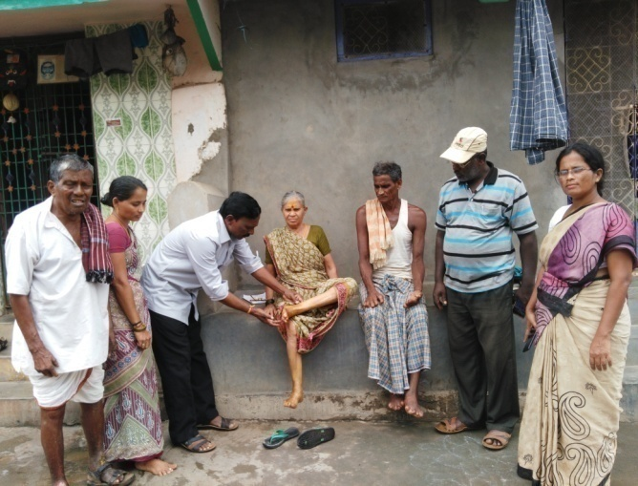
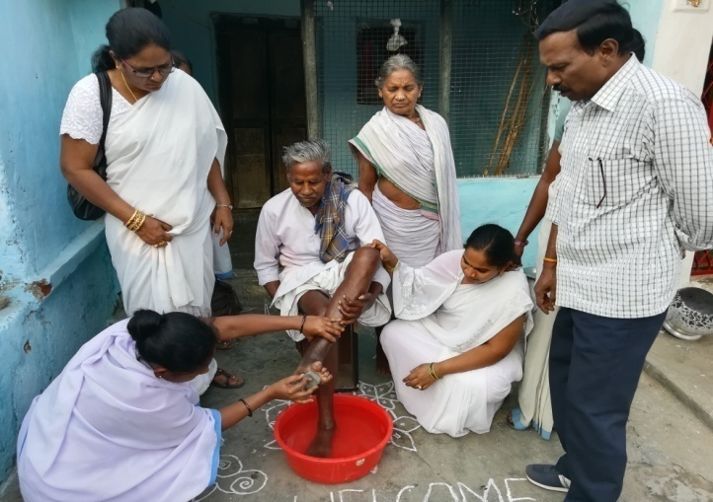

Demonstration of home based self care

- 11 Disability care camps were organised along with GH staff, ANMs & ASHSs. 259 beneficiaries have attended and 63 cases were demonstrated self care practices.
School survey was done in 46 schools and 3031 children were examined. 1 child case was
detected.

- 6 training programmes were conducted to 844 (240 health staff & 604 ASHA) in 6 PHCs to strengthen their participation in leprosy programme. The training was more focused on cardinal signs of leprosy, physical examination for identification of suspects & their referral to PHCs, treatment follow up & strengthening of referral services.
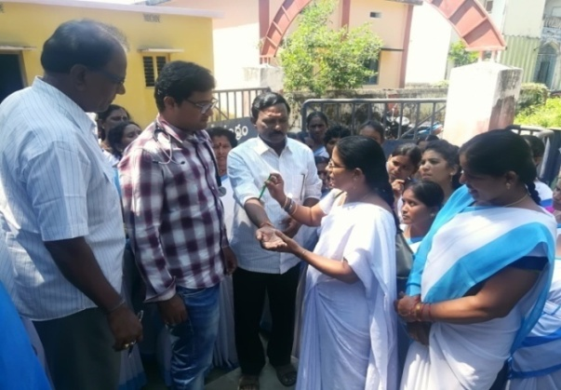
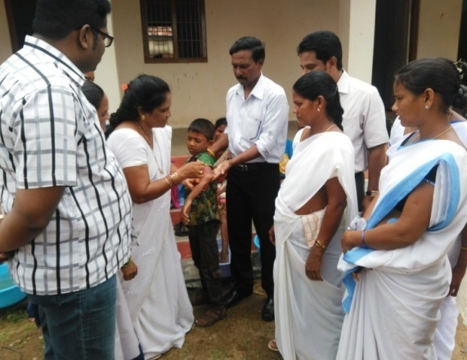

- 4 Sensitization programmes on leprosy were conducted to 234 village volunteers. The programme was to acquaint the volunteers with early signs of leprosy and referral of suspects
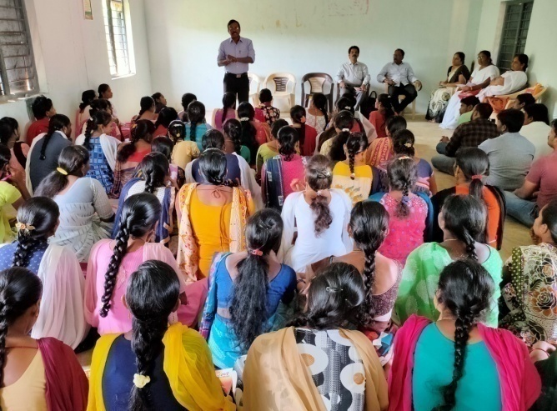
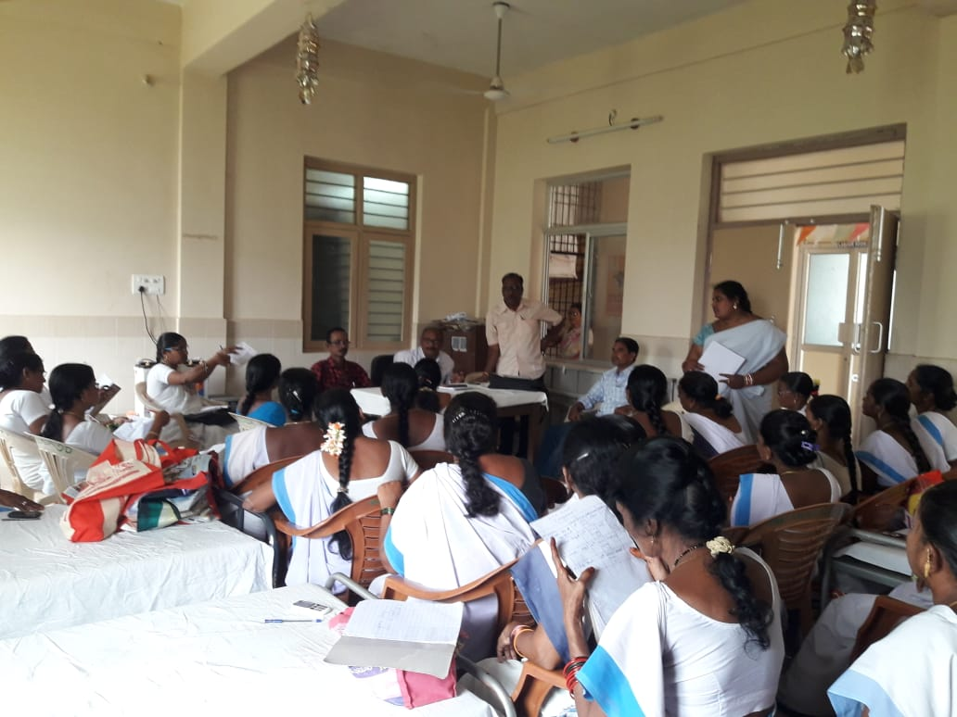

- 10 leprosy affected children (4 M & 6 F) were identified and referred to TLM for education support sponsored by CUFA (Children unite For Action). Rs.5000/- was given to each child towards Uniform, books, school bag and nutrition support.
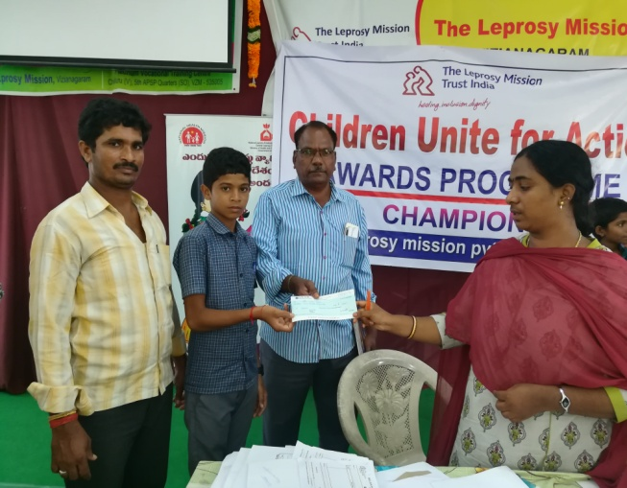
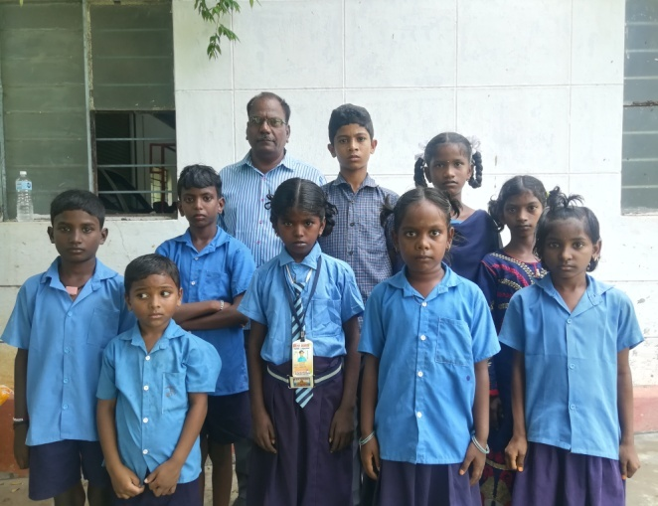

Children identified Handing over cheques through Project staff
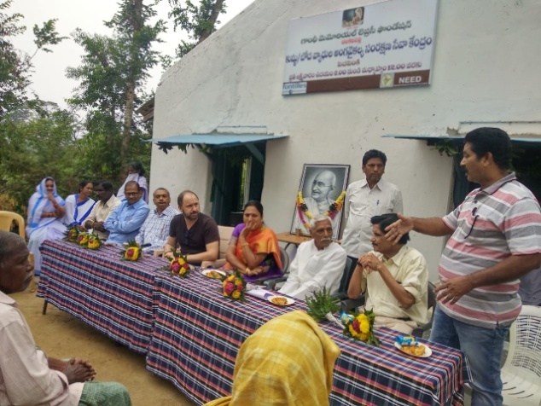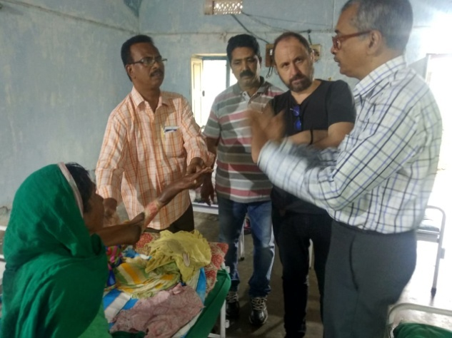
Country Director visit photos
CCI (CHILDREN CARE INDIA
AIPE INTERNATIONAL, CANADA

The CCI has kindly sanctioned the following projects to our NEED organisation for their development.

- Children Education
- Micro Credit
- Anganwadi School
About CCI : CHILDREN’S CARE INTERNATIONAL (CCI) — better known locally as Aide internationale pour l’enfance (AIPE) — is a non-profit non-governmental organisation founded in 2000, working in the field of international aid and cooperation. It has distinguished itself through its two-fold mission:
- liberating children and their families from poverty and exploitation
- at the same time, raising the developed world’s awareness of issues relating to child labour by encouraging the public to engage in concrete efforts of solidarity.
Children Education:

We have supported to 60 children from 16 villages for their studies that who are totally poor and child labour, and some of them are orphan and semi orphan children, most of the children are come from fishing community, at present some children finished their studies and some children dropped out from their studies, so this year CCI project is supporting 23 children for their studies. They are studying in 12 centers in different places. Some of them are in job trails, they are searching for jobs, so we have visited their colleges once in a week those which are in Vizianagaram and closed to viziangaram and visited other colleges once or twice in a month those which are in visakhpaatnam and closed to Visakhapatnam. I have visisted all colleges, hostels and rooms and interactedwith children and discussed with them about thir health, education progress and their requirements, they said that they are fine and studying well and also they wanted tuition fee, hostel fee, room rents, food expenses, uniforms, tavelling expenss, books, stationary and other requirements. So I have provided uniforms, travelling expenses, books and other requirements. So I have provided uniforms, travelling expenses, books and other expenses, books and other requirements in time that which they needed, and also I discussed with their teachers about our children regularity and education proress. And also I interested with other children that who are in job trails and discussed with them frequently about their progress.

Micro Credit:
Microcredit program for marginalised women
Single women are marginalized in Indian society; its social stratification is designed in such a way as to exclude such persons from ordinary society. The social stigma associated with divorce still weighs heavily on women, usually housewives who depend on their spouses, and life alone can be cruel and oppressive to women because they are perceived as only being complete when they are married.
CCI gave itself as a mission to break the cycle of poverty and indentured slavery. Single women are often forced to borrow from loan sharks in order to be able to cope with unforeseen expenses such as health costs. Once deep in debt, they find themselves unable to repay the amounts borrowed, and are forced to send their children out to work. Since 2007 CCI launched a microcredit programme in the community of Vizianagaram.
It is an effective way to generate a source of income for poor women, enabling them to eliminate their debts and develop financial independence. It makes it possible for them to create or maintain small businesses without having to go into debt.
However, to benefit from this programme, there is one strict condition: their children must to be enrolled in and attend school. Once approved, beneficiaries receive a small interest-free loan which, however modest, greatly improves—sometimes radically—their quality of life.
By guaranteeing access to education for their children, and financial opportunities to families through the use of microcredit, CCI makes it possible to break the vicious cycle of indebtedness and avoid its perpetuity. The microcredit programme and its efforts in supporting education are a huge success. Today, women who have joined the project are investors in education.
Objectives of the project:
• Enabling women targeted by the project to become entrepreneurs
• In the short term, promoting an increase in beneficiaries’ income
• In the medium term, enabling the schooling of children as well as more systematic access to health care
• Finally in the long term, making it possible for women—who have often lived their entire life being undervalued and marginalised—to have the chance to become autonomous and develop their self-esteem.
Their vulnerability is considerably reduced because they increase their capacity to act, which improves the quality of life for their families, their communities, and future generations
Anganwadi School:

With the support of CCI, we have organized one Anganwadi school at our Vizianagaram district, in this school 14 children’s. In this Anganwadi School we have provided the following facilities to all children.

- Play material
- Nutrition food
- Teachers & Aaya

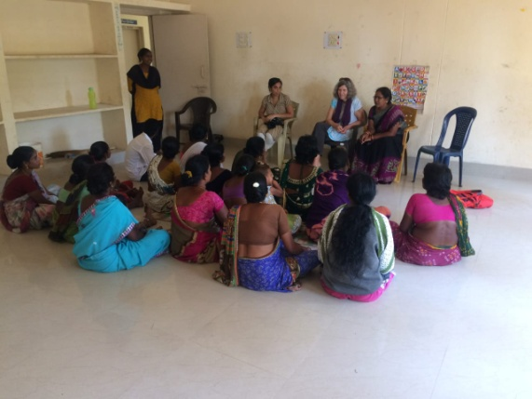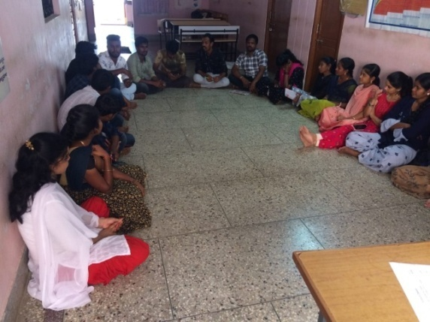

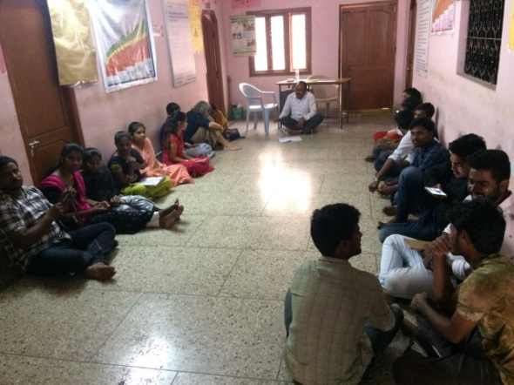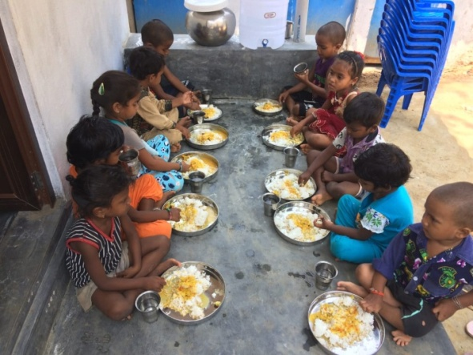

OPEN SHELTER
In the year 2013-2014 the Department of Juvenile Welfare correctional services and welfare of street children department, Vijayawada, Andhra Pradesh has sanctioned an “OPEN SHELTER” to 25 no of children at Salur (Urban).
On 01.04.2013 we have established an Open shelter in Salur urban with 3 contact points at Railway station, Bus Stand and Town Market. The work of the contact point is to discover the children of 18 years below;
The major activities of this project is to provide institutional care facilities to the Street children, Child beggars, Waste paper collectors, Working children, Street performers, Orphan children, Deserted and abandoned children, Migrant children, neglected families children etc.
We have reached the following objectives and goals of the project in this year:
- We have protected them from the vulnerable life situation.
- We have protected from High risk and socially deviant behavior.
- Increased their life skills.
- Introduced them into the appropriate education with their age.
- Provided Education, Nutrition food, Good clothing etc to them.
Children admission and moving Details approved by CWC, Vizianagaram:
NEED OF OPEN SHELTERS FOR CHILDREN IN URBAN AND SEMI-URBAN AREAS :
1. The largest numbers of homeless children, pavement dwellers, street and working children, child substance abusers and child beggars, left on their own and in need of care and support, reside in urban areas. They are seen living in conditions of extreme deprivation compounded by lack of shelter and access to basic services like sanitation, safe drinking water, education, health care, recreational facilities, etc. They end up at traffic intersections, railway stations, streets, vegetable market, etc. begging for alms, wiping automobile windscreens, rag picking, vending wares. These children are very often victims of adult abuse of all kinds: physical, sexual, emotional as well as economic exploitation. Inhuman and violent life conditions turn many of these children into law offenders, criminals and exploiters themselves.
2. Amongst these children, a large number of child substance abusers have also been identified by government through civil society organisations working in these areas. Inhalant (popularly known as solution) is the most commonly used substance among these children, though some of the children also move on to other substances such as cocaine etc. The usage pattern among the children is also dreadful. It was understood that major part of the money earned by the children is spent on drugs. They may also be involved in petty thefts, drug peddling or controlled by a begging or stealing groups. Many of these children also peddle sex for survival and paedophilia is common. Besides, urban areas also include a large number of unauthorised slums and other areas which are hubs of sex trafficking which are particularly unsafe for children living there, making them vulnerable to age-inappropriate information, second generation prostitution etc. ICPS also caters to the needs of such children including, prevention, treatment and rehabilitation through services of these Open shelters.
3. This flexible mechanism of Open Shelters is catering to the unique needs of these children particularly in urban areas and aims to harness their talent and potential, thus giving them the opportunity to become productive citizens. These are community based safe spaces which provide a space for children where they can play, study, use their time productively and engage themselves in creative activities through music, dance, drama, yoga & meditation, computers, indoor and outdoor games, etc. in a safe environment and located within their own community.
4. These activities encourage meaningful peer group participation and interaction. This ensures the overall growth and development of children and keeps them away from socially deviant behaviours, in addition to fulfilling their basic requirements for food, nutrition and health. These Open Shelters also have provisions for health care, quality and flexi-time education (including connecting with mainstream schools) and vocational training and have space where children can safely keep their belongings and earnings. Counselling guidance and life skill education are also provided here for channelizing these children’s energy into productive endeavours. In the long term, the aim is to make them self reliant, aware and wean them away from street life or dysfunctional behaviours.
5. Target Group Open Shelters in urban and semi-urban areas will cater to all children in need of care and protection particularly beggars, child substance abusers, street and working children, rag pickers, small vendors, street performers, orphaned, deserted, trafficked and run-away children, children of migrant population, children living in unauthorized areas/slums, children of socially marginalized groups and any other vulnerable group of children.
6. Objectives These Open Shelters, run by both NGOs and State Governments/UTs, are not meant to provide permanent residential facilities for children but will complement the existing institutional care facilities. The objectives of these Open Shelters include: (i) To attract above-mentioned target group of children from their present vulnerable life situation to a safe environment; (ii) To wean these children away from the vulnerable situations by sustained interventions; (iii) To guide these children away from high risk and socially deviant behaviors; (iv) To provide opportunities for education and develop their potential and talent; (v) To enhance life-skills and reduce their vulnerabilities to exploitation; (vi) To reintegrate these children into families, alternative care and community; (vii) To carryout out regular follow up to ensure that children do not return to vulnerable situations.

7. Programs and activities
- Identifying such children within the geographical area/location of the Open Shelters;
- We are using innovative child friendly approaches and outreach activities to make contact with them;
- Our NEED Organization establishing such Open Shelters could supplement their services through Contact Locations that established on railway platforms, crowded market areas, tourist destinations, bus stands, etc.;
- Contact Locations established by organizations running the 24-hour Open Shelters or their partners;
- Using techniques like music, drama, storytelling, outings and other child friendly methodologies to attract and sustain the interest of the children;
- Our NEED Open Shelters introduce age appropriate education, access to vocational training, recreation, bridge education, linkages to the National Open School Program (NOSP), health care, counseling, etc.
- In order to providing useful vocational training to children, and tie up with other NGOs and ITIs to either provide vocational training facilities by sending the children to such NGOs or ITIs or provide such facilities within the Open Shelter;
- Providing individual specific needs like substance abuse, behavioral problems and socially deviant behaviors among others;
- Encourage involvement of social workers, community volunteers, peer educators, students and others. They are providing opportunity to people with skills and time to mentor, guide and improve the quality of life of these children;
- Providing life skills to children leading to personality enhancement, raising self esteem, developing a positive approach to life, improving communication skills, ability to deal with trauma, reducing risk and vulnerabilities, etc.;
- Providing temporary stay facilities for children; and children requiring long term care shall be referred to the nearest Shelter/Children’s home;
- Function as 24- hour Crisis Management Centres to receive and provide necessary assistance to children;
- Providing quality toilets, lockers for children to keep their belongings, washing facilities, recreational facilities both indoor and outdoor, etc.;
- Providing health care facilities and refer children for specialized services for prevention of drug and substance abuse, HIV/AIDS/STIs and other chronic health disorders;
- Maintaining standards of care and children should be encouraged to participate in the activities of Open Shelters;
- Preparing Individual Care Plan for each child which will be monitored by the DCPU from time to time;
- Maintaining electronic data of each child and furnish the details to the DCPU as a part of the child tracking system and provide list of names of children accessing services to the Child Welfare Committee whenever directed to do so.
8. Accommodation facilities provided:
(i) A Unit is maintaining for 25 children and carpet area of 2000 sq ft. including a kitchen, two bathrooms and two toilets.
(ii) NEED running these Open Shelters contact with Municipal Corporations, Zila Parishads, Slum Boards, Railway and Transport authorities for suitable accommodation for Open shelters or contact points.
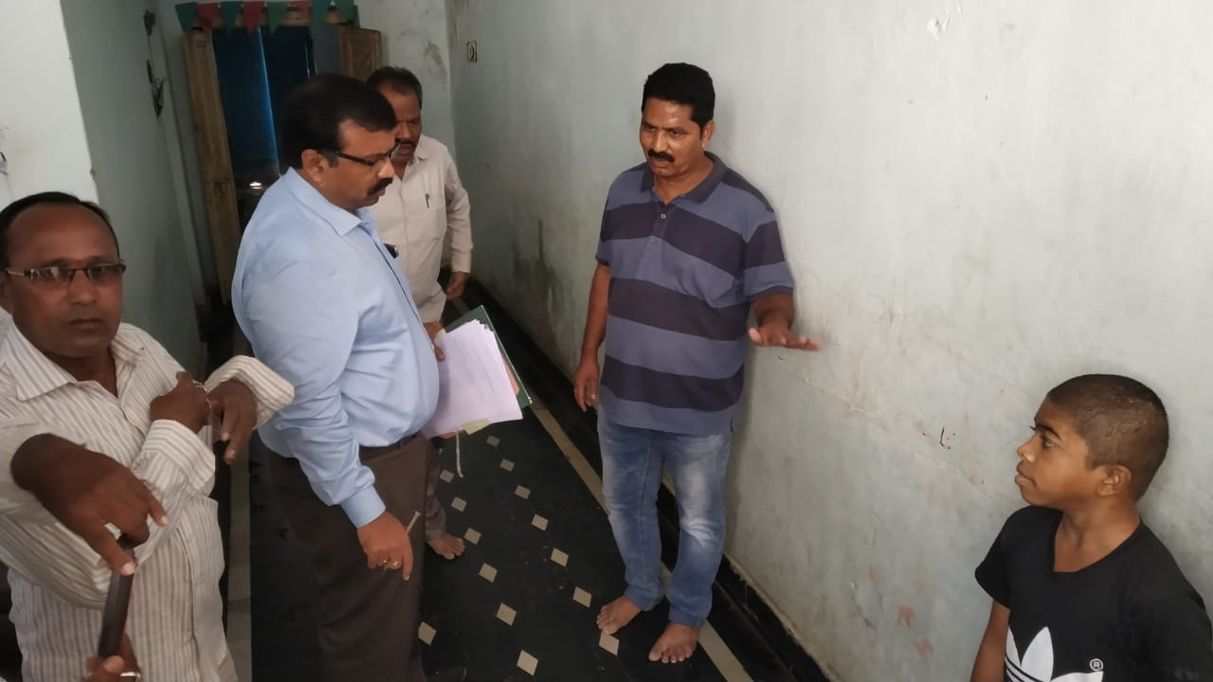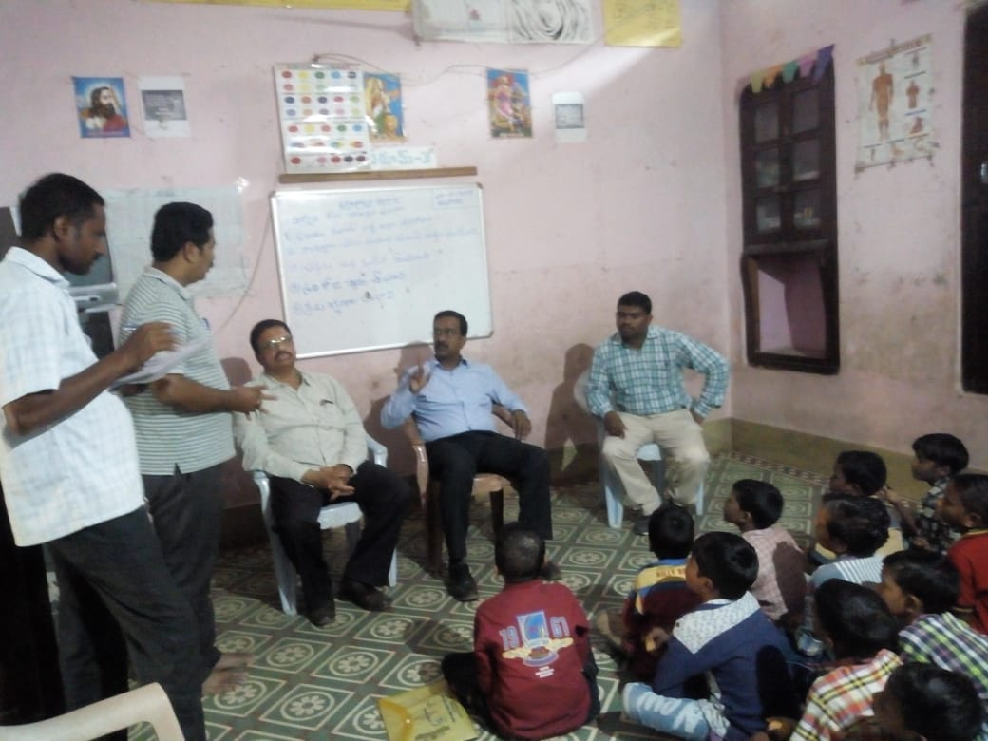
Sri.Srihari Garu, District Judge, Vizianagaram visits Open Shelter, Salur & Joint director Mr.Sri.Prasada Murthy & RIP, DPO visits open shelter project under NEED, Salur.
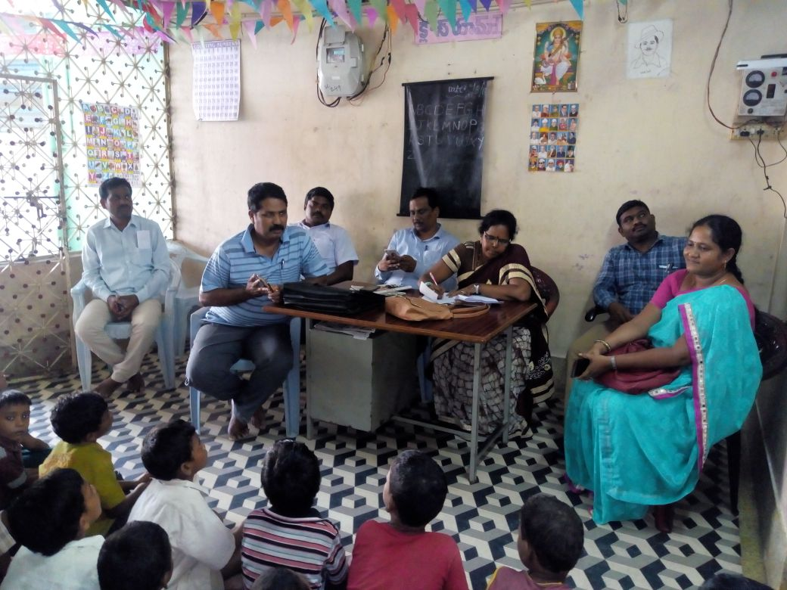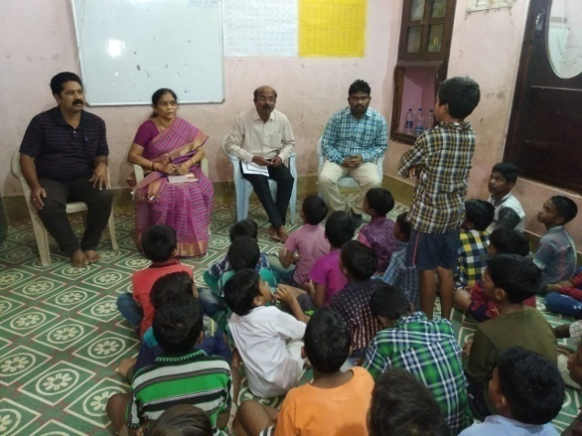
Smt.Lakshmi, DCPO and Child Welfare Committee (CWC) Team visits Open shelter, Salur & MRO, DPO, Women & BC Welfare Officer visits open shelter.
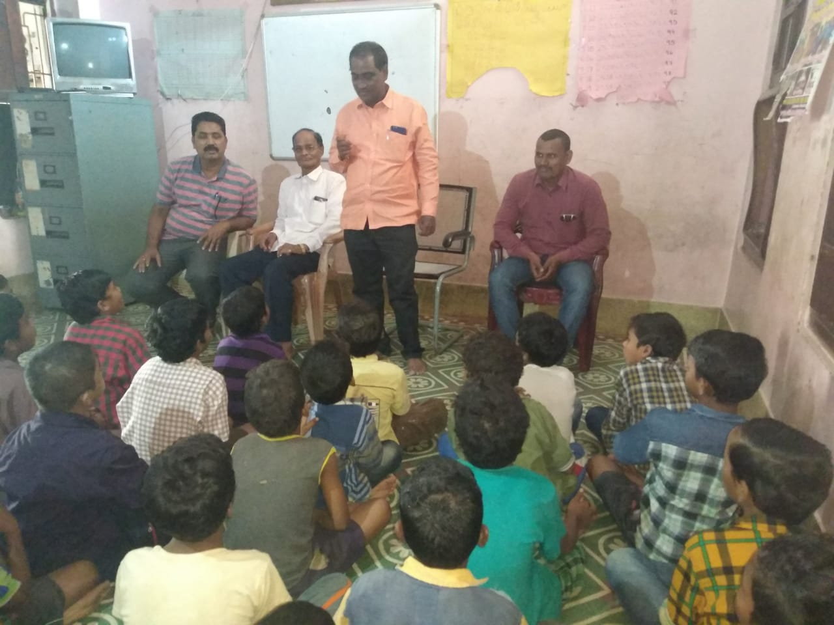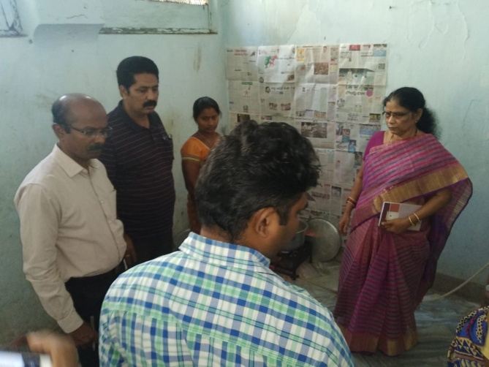
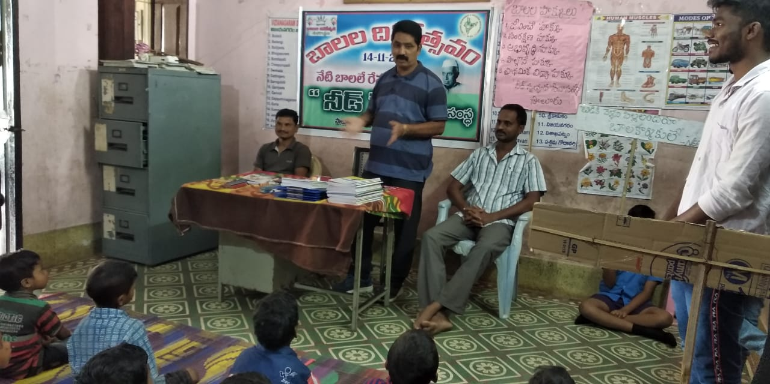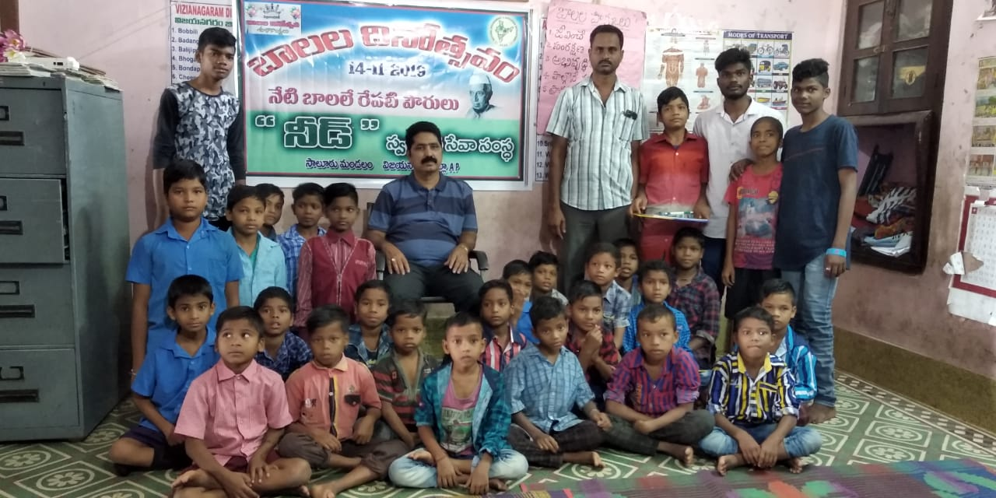
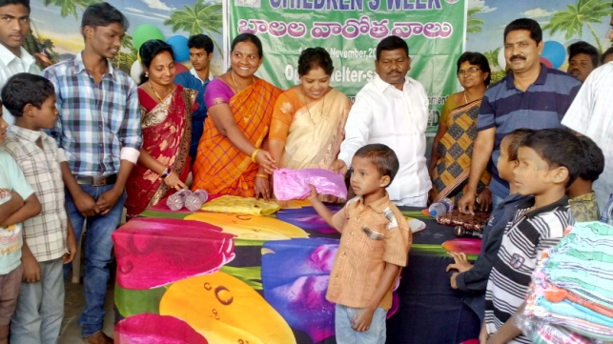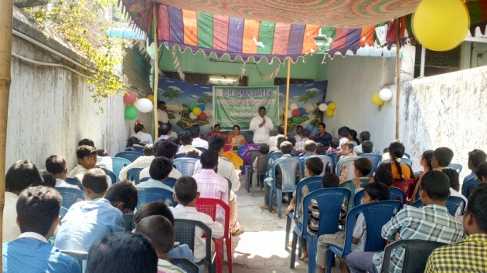

Sri.P.Rajannadora Garu, M.L.A and Smt.G.Sandhya Rani, MLC has distributed books, blankets to open shelter children in the occasion of Childrens week

URBAN RESIDENTIAL HOSTEL, VIZIANAGARAM.

About the Urban Residential Hostel:

The Samagra Siksha Abhiyan (SSA), Vizianagaram has kindly sanctioned the Programme to NEED organisation in the month of July 16th 2012, from onwards the project is implementing at Near Municipal High School, Cantonment, Vizianagaram with 100 Urban Deprived Children.

In this project we are implementing the following activities with the support of RVM (SSA), Vizianagaram.

ACTIVITIES

- Regular Tuitions – Morning / Evening
- Health Check ups
- Counseling services to children & parents
- Recreation activities
- Sports
- Regular follow up/ monitoring
- Parents meetings
- Children’s review meetings
- Birthday and Events celebrations
- National Days celebrations
- Festivals celebrations
- Exposure visits / Science fairs
- Staff Review meetings

Regular Tuitions – Morning / Evening

We have regularly conducting tuitions for all 100 children (3rd standard to 10th standard) at their class rooms, for this purpose we have appointed 3 tuitors and they are professionally qualified and well trained. In this section our tuitors are conducting tuitions from morning 6.30 a.m. to 7.30 a.m. and evening 6.30 p.m. to 7.30 p.m. in this classes our tuitors are clarifying their doubts, we have providing some more knowledge to children on their subjects. After completion of their tuitions we have provided snacks to all children’s.

Health Checkups

We have regularly conducting Health Checkups with the support of Govt.Doctor, every month we have conducting two times in our Hostel for all of our 100 children, in this camps we have identified any health problems then we have to refer near government hospital or KGH, Visakhapatnam.

Counseling services to Children’s & Parents:

We have regularly providing counseling services to our children’s and parents, especially in School holidays, for this purpose the SSA, Vizianagaram has sanctioned one councellor post to our URH, the councellor has regularly providing counseling services to all of our children, especially home sick and backlog students and at the same time we have provided councelling services to parents also, some parents are motivated from our councelling services.

Recreation Activities:

Our Hostel warden, Tuitors, Councellor has provided recreation activities at the time of school holidays and festival days, sometimes after school completion we have provided recreation activities to our children, in this recreation activities most of the children are playing Cricket, caroms, Chess, wallyball etc., (Indoor and outdoor games), and we have provided YOGA classes to our children for their improvement in mentally and physically.

Sports:

We have regularly conducted Sports to all our children, our Urban Residential hostel is located in Cantonment High school, we have a big play ground, in this ground all the children are playing Cricket, wallyball, etc., outdoor games, we have also encouraged to play games in evening times.

Regular follow-up monitoring:

We have strong monitoring system in our URH, the Warden and project Director of NEED is regularly monitoring the regular activities and programmes at the hostel, every day warden has monitoring the tuitions, food quantity and quality, cooks timings, menu implementation etc., activities.

Parents Meetings:

Our councellor has providing Parents meetings and counseling sessions at the time of Sundays and public holidays; in this meeting we have explained children education status, school attendance, problems, Child marriages, issues and discussion on their children studies.

Children’s review meetings:

Our Project Director, hostel warden and councellor has conducting childrens review meeting every week at our Hostel, in this review meeting we have discussion on their problems, progress, studies, issues etc., and in this review meeting we have providing counseling services also.

Birthdays and event celebrations:

We have conducted Birthdays and event celebrations at our hostel, some of the donors or our Project director has sponsored the Cake and balloons and other materials to conduct the Birthdays and event celebrations at our hostel, for these celebrations, every children feels happy and build their self confidence levels.
National Days celebrations:

We have conducted National Days like August, 15th, January 26th, 2nd October etc., days, in those days we have specially provided special food like Biryani, sweet, pongal etc., and we have explained the days importance to all children.

Festival Celebrations:

We have organized seasonal festivals like Vinayakachavathi, Dasara, deepavali etc., and explain the importance and background of the festivals. In those celebrations all the children’s are happily participated and involved.

Exposure visits/science fairs:

Seasonally we have conducted exposure visits to all of our URH children and they are enabling their knowledge and experiences, for this programme the SSA, Vizianagaram has also supported.

Staff Review Meetings:

We have conducted monthly staff review meetings with our staff at our hostel, in this meeting we have discussed on their performance and total achievements, we have also supported to all staff in the areas of their roles and responsibilities.

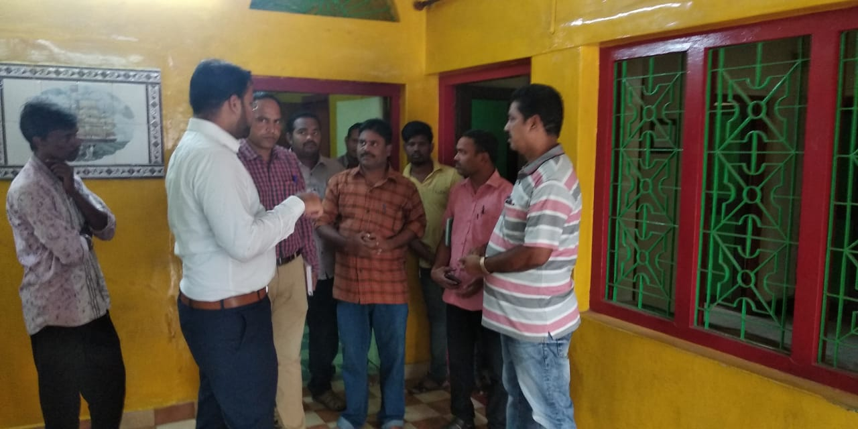

Sri.Ketan Garg, I.A.S., Asst.Collector, Vizianagaram has provides suggestions to NEED director for implementation of Urban Residential Hostel, Viziangaram.
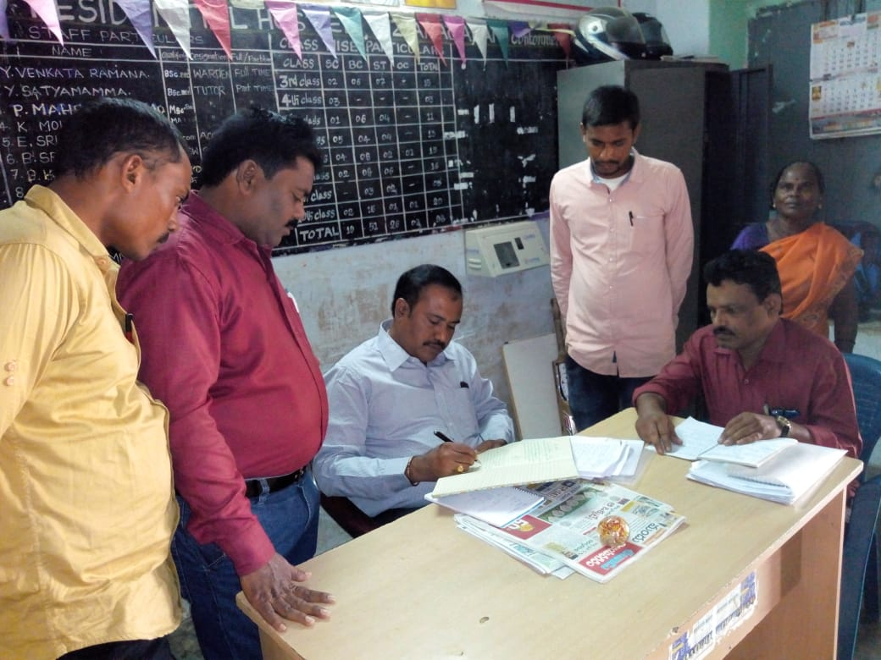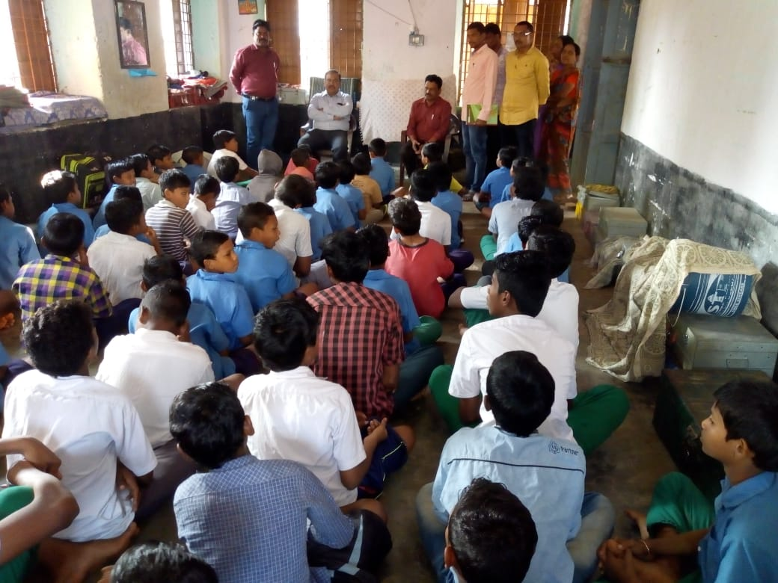

State Observator, SSA visits URH, Vizianagaram.

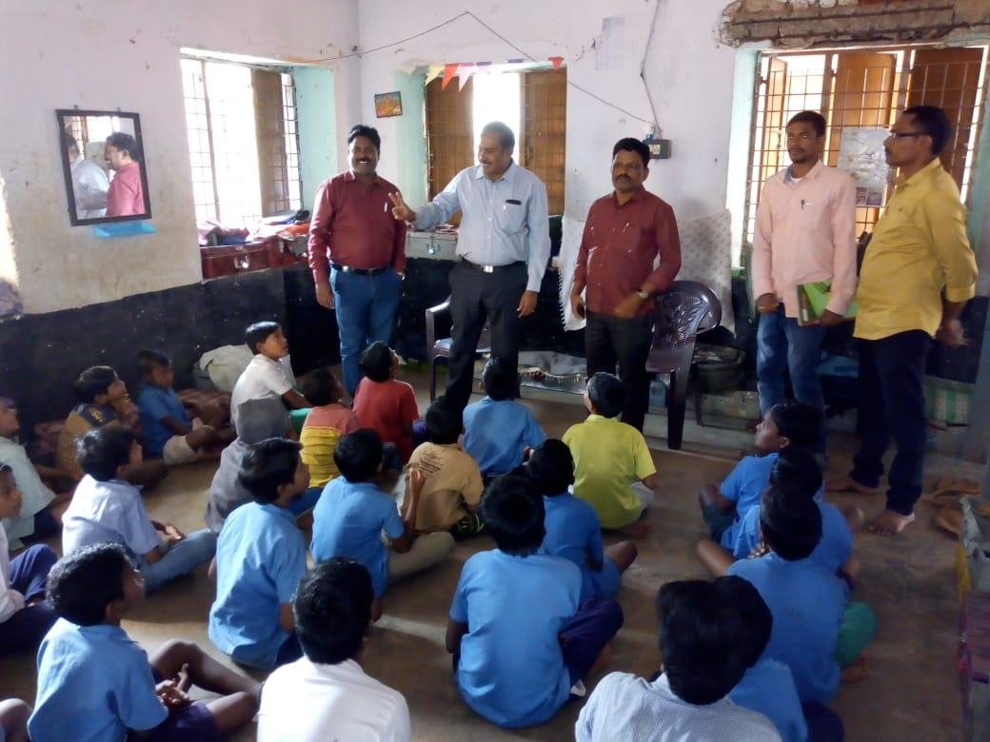

State Observator and Trainee Collector visits Urban Residential Hostel Programme at Cantonment under NEED, Vizianagaram.

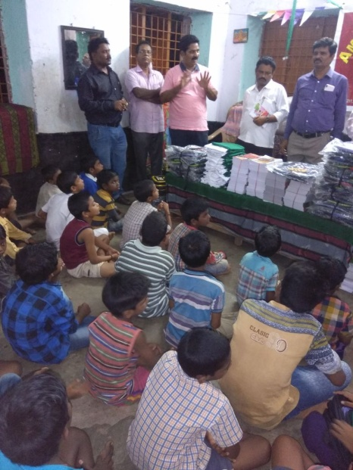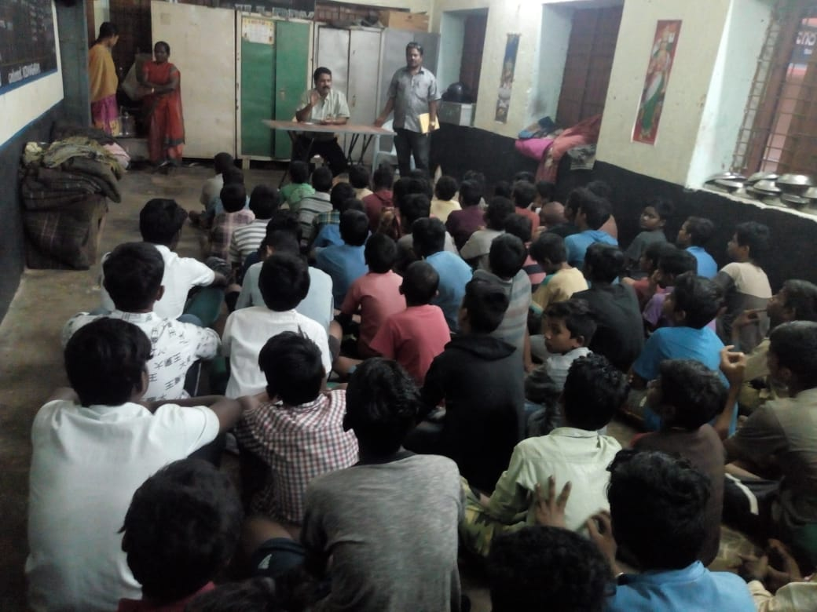
NEED Director Mr.P.Venugopala Rao distribute Books to children and motivational speech by Mr.Venugopala Rao.
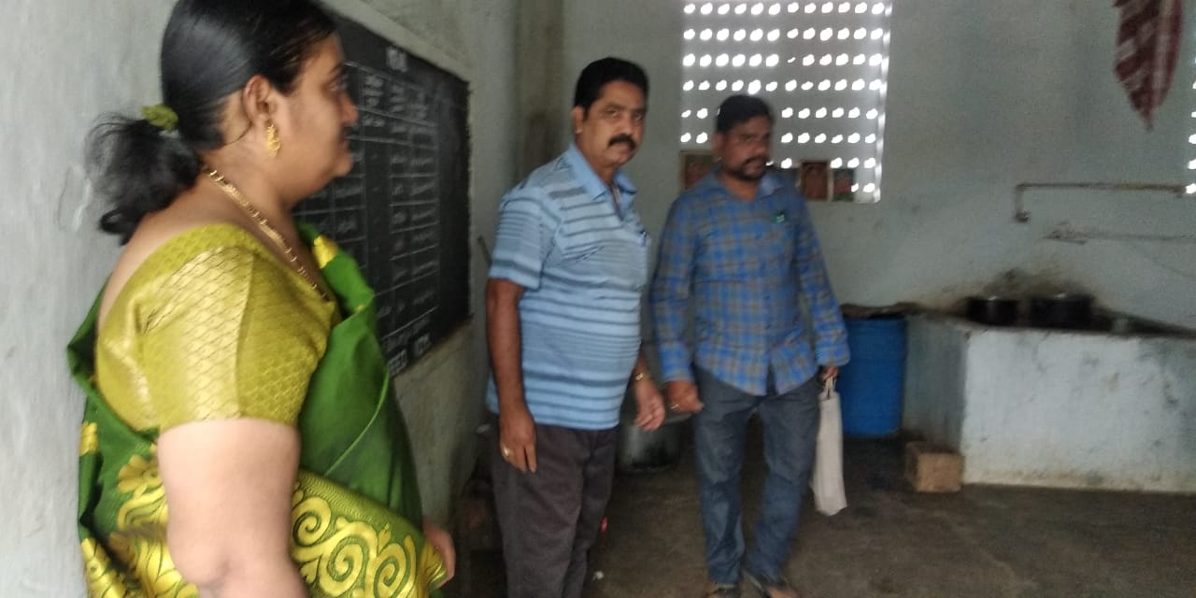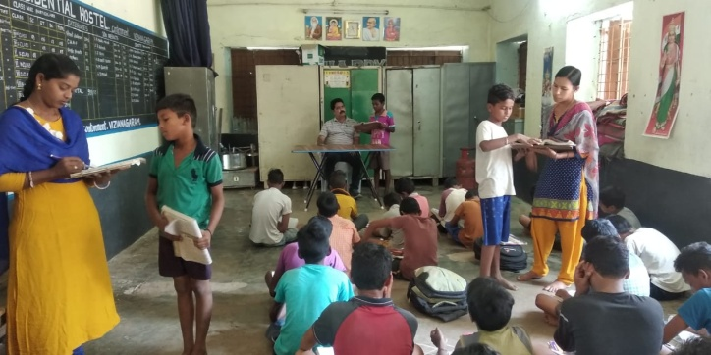
Honourable District Judge visits URH and SSA, Vizianagaram Officials visits URH and Tuitors are involving in tuitions at Morning & Evening times.
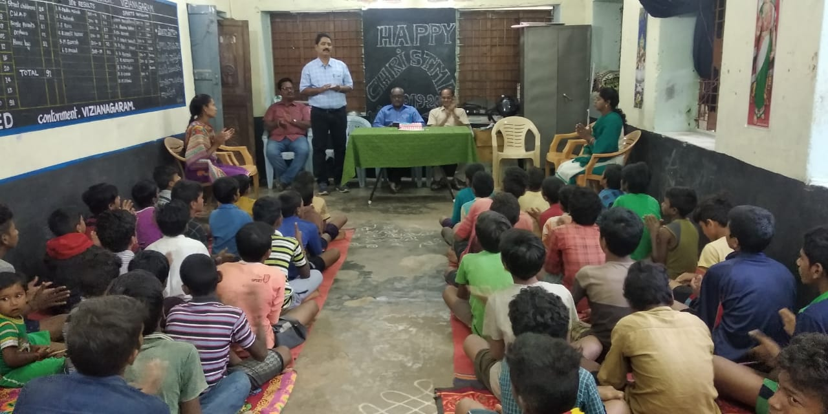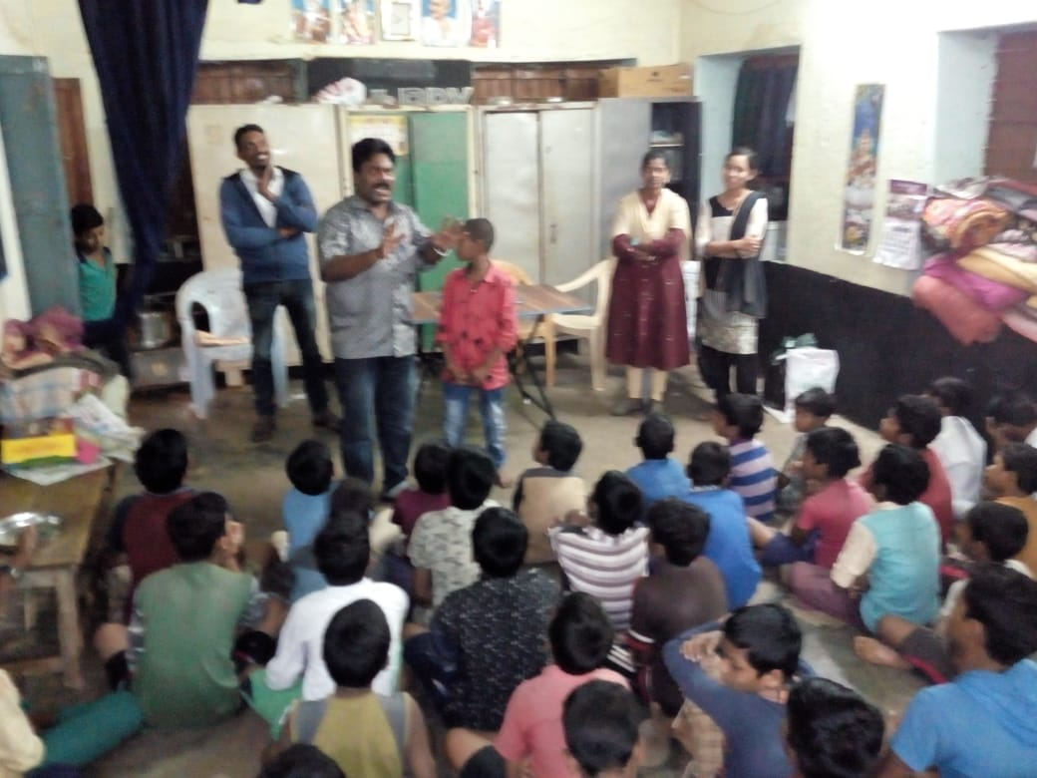
Christmas Celebrations at URH Hostel
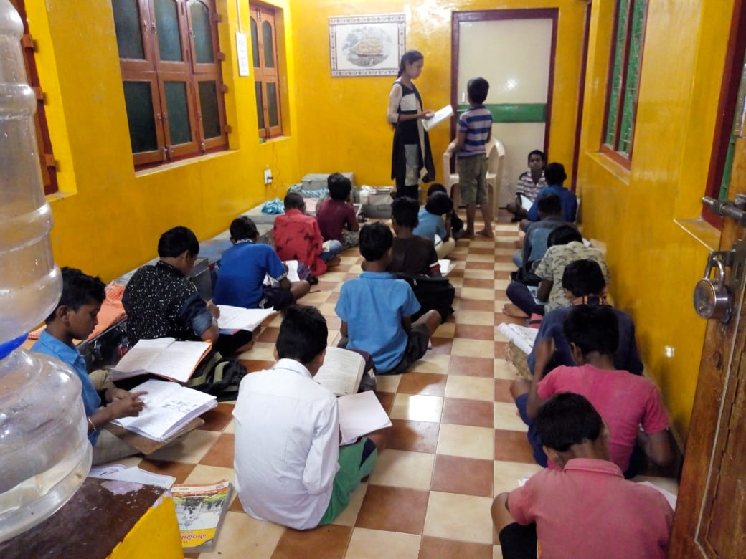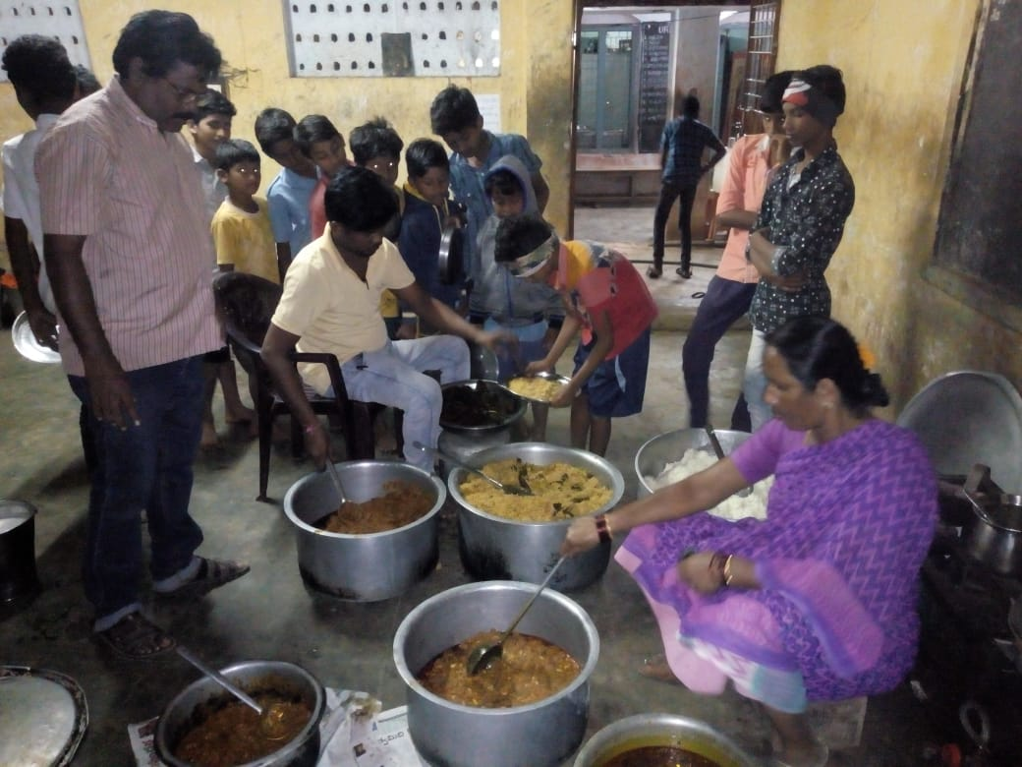

Evening tuitions and Night Dinner distribution to children at URH.. Mr. Mohan, Hostel Warden monitoring the food distribution

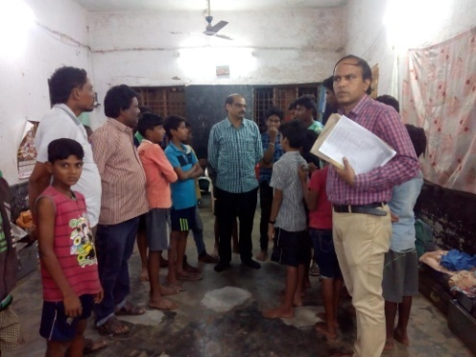
Project Officer and ALS coordinator interacted with Children and staff regarding the facilities provided by NEED.
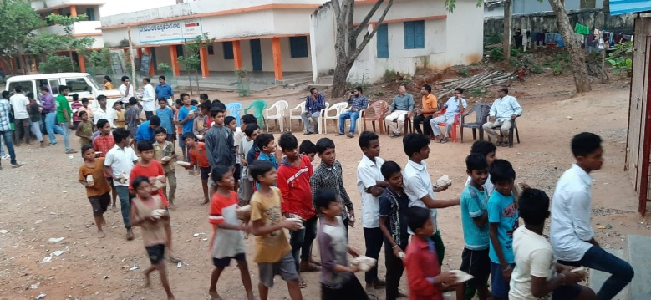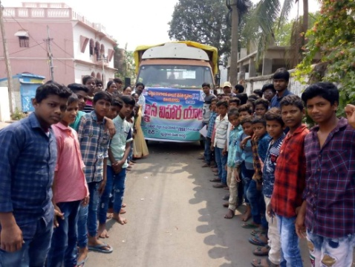
URH Children came from School to URH and Exposure visit of URH Children.

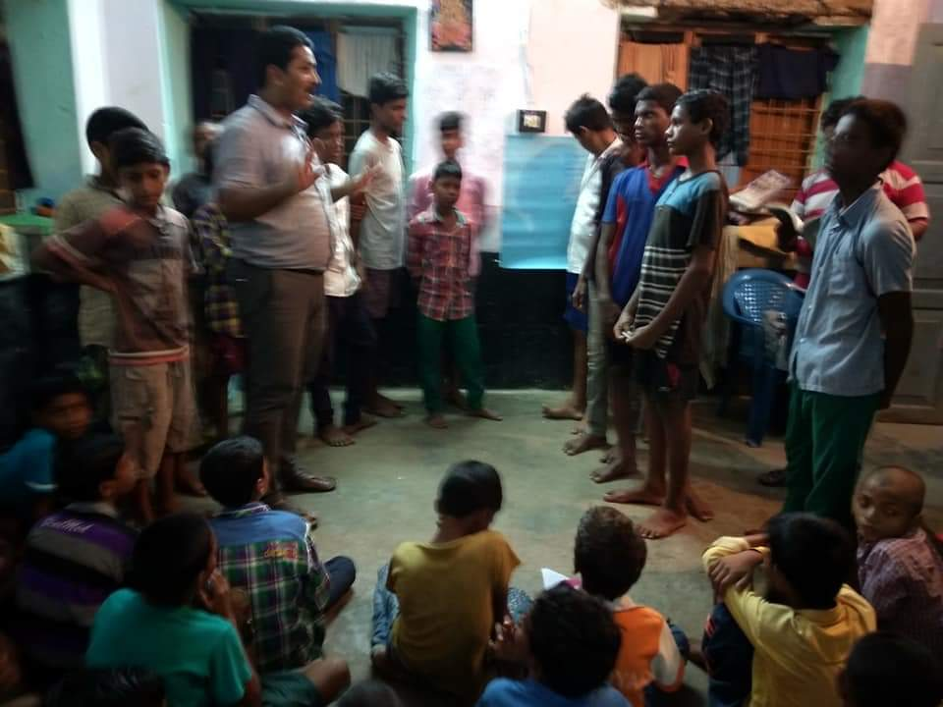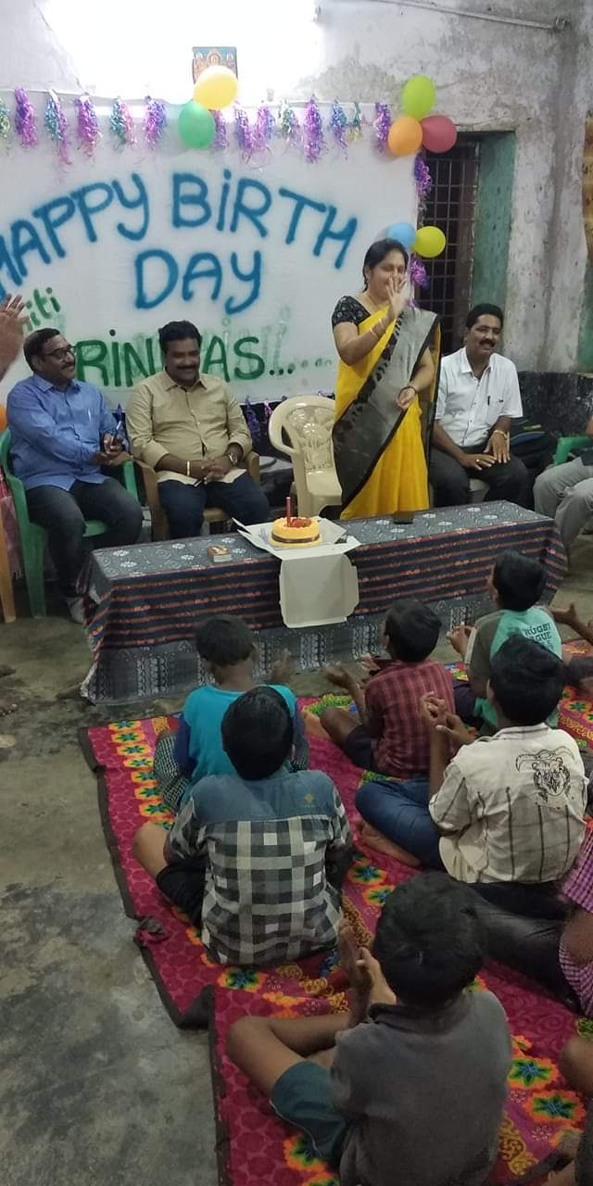
Mr.P.Venugopala Rao provides councelling sessions to URH Children and DEO Nagamani garu attended Birthday celebrations at URH, Vizianagaram.

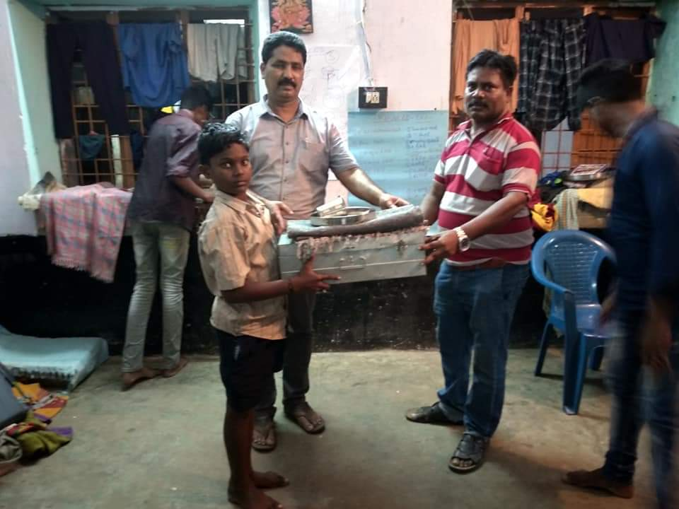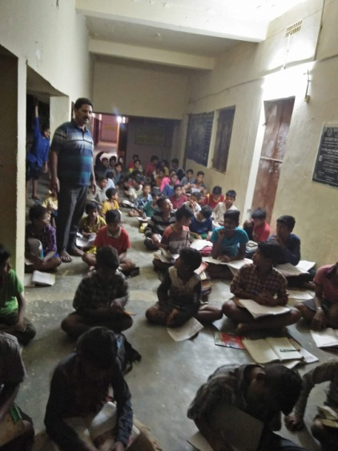
Mr.Venugopala Rao and Mr.Mohan, Hostel Warden distributing Iron Boxes to children along with bed sheets, books and etc material. Mr.Venugopala Rao garu monitoring night study hours at URH Hostel.

BASIX India – FPO

We have implemented this project in Visakhapatnam & Vizianagaram Districts with the support of Basics India, FPO. The Project particulars are as given below:

About Basix: BASIX is a livelihood promotion institution established in 1996, working with over a 3.5 million customers, over 90% being rural poor households and about 10% urban slum dwellers. BASIX works in 18 states - Andhra Pradesh, Karnataka, Orissa, Jharkhand, Maharashtra, Madhya Pradesh, Tamilnadu, Rajasthan, Bihar, Chattisgarh, West Bengal, Delhi, Uttarakhand, Sikkim, Meghalaya, Assam, Gujarat and Jammu & Kashmir, 223 districts and over 39,251 villages. BASIX mission is to promote a large number of sustainable livelihoods, including for the rural poor and women, through the provision of financial services and technical assistance in an integrated manner. BASIX will strive to yield a competitive rate of return to its investors so as to be able to access mainstream capital and human resources on a continuous basis. BASIX strategy is to provide a comprehensive set of livelihood promotion services which include Financial Inclusion Services (FINS), Agricultural / Business Development Services (Ag/BDS) and Institutional Development Services (IDS) to rural poor households under one umbrella.
VALUES
BASIX is deeply committed to promoting livelihoods for the poor, and have a strong concern for
- equity – working with the rural and urban poor
- sustainability – both financial and institutional for BASIX and also for its customers and for the environment
- results – making things happen on the ground as well as scale up directly and indirectly through influencing others including government policy and programs
- integrity and dignity – ensuring these for those who we work with and those who work in BASIX
- Innovation and learning - devising new ways of doing things and mastering those
We are doing the FPO (farmer producer Organizations) at Visakhapatnam & Vizianagaram Districts; in this project we have given the following information to farmer and community:

- Identification of farmers & crops and cultivation
- Horticulture crops identification
- Groups formation
- Providing trainings
- Value addition
- Marketing linkages
- Proper documentation
- Proper knowledge

FARMER PRODUCER ORGANISATION/COMPANIES – MEETING PHOTOS

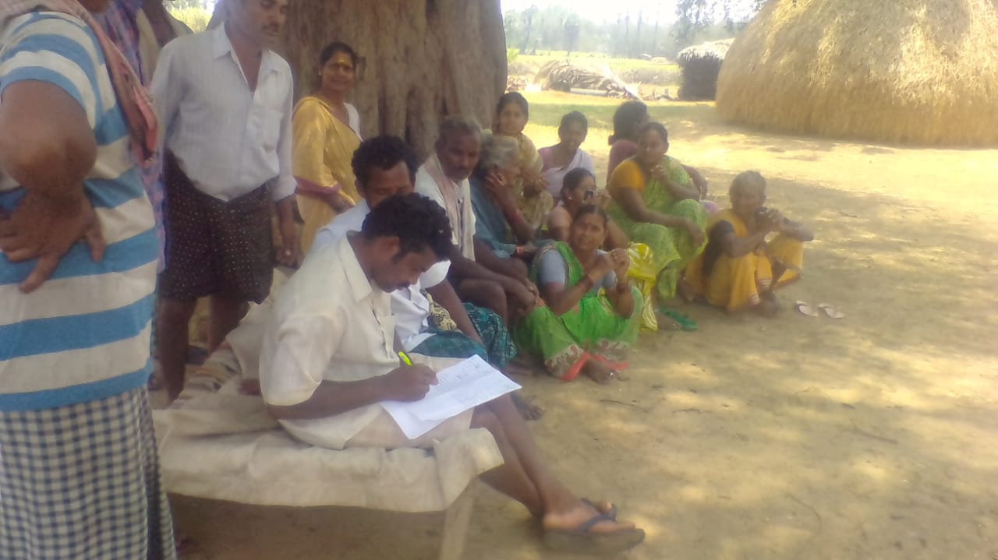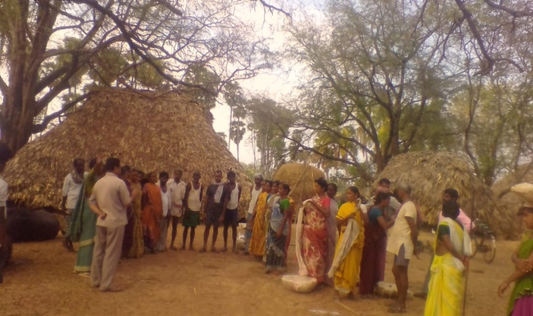

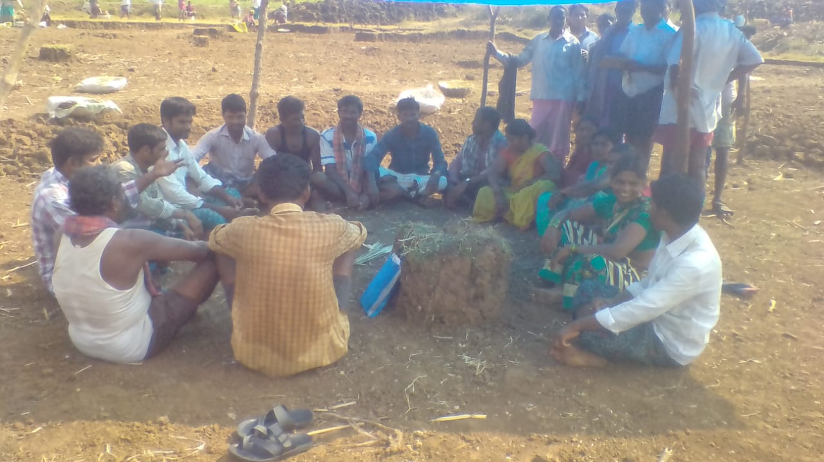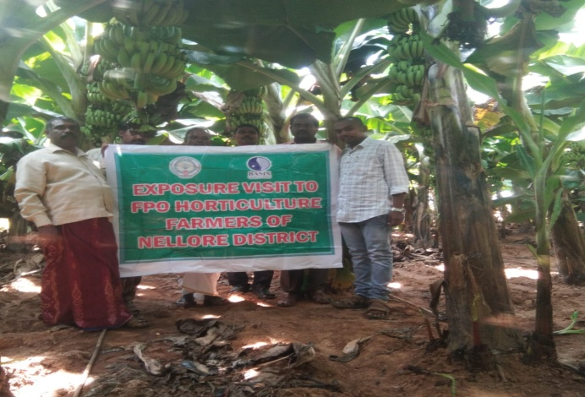

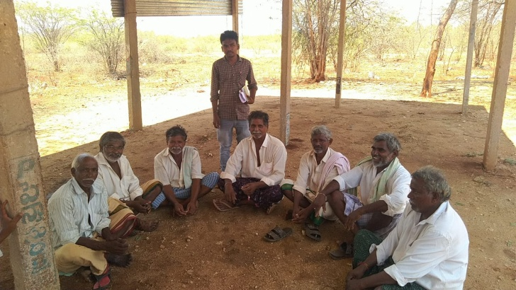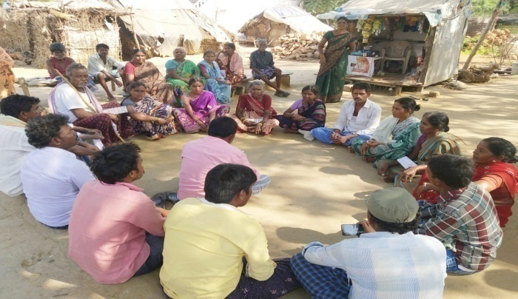

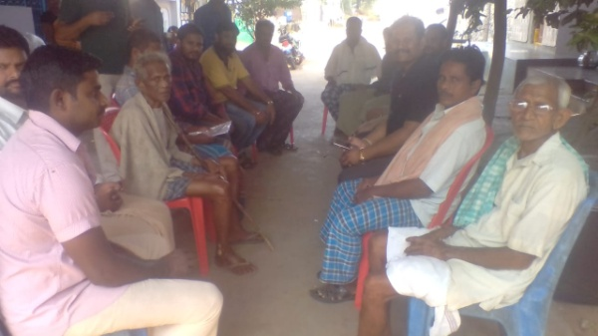

ZBNF
ZERO BUDGET NATURAL FARMING PROGRAMME

- Background
At present we are implementing this programme in Salur, Pachipenta and Makkuva Mandals, Vizianagaram district; through this programme we have covered 1500 farmers and they are
Andhra Pradesh is a major agriculture hub in India. Agriculture being one of the key economic sectors, it plays an important role in the livelihoods of people by employing nearly 62% of population in agriculture and allied activities. Agriculture contributes to 28% of state GSDP. Andhra Pradesh is also known as Rice Bowl of India and has a diversified cropping system – covering 80 lakh hectares of land in cropped area. Andhra Pradesh is India’s largest producer of fruits, eggs and aquaculture products. About 14 lakh hectares are under Horticulture. The main challenges in Agriculture and Food sector can be described as follows:
Farmer Distress
Farmers are in deep distress. The conventional agriculture practice induces the farmer to rely heavily on chemical fertilizers and pesticides leading to high cost of cultivation. Prolonged dry spells and drying of borewells coupled with extreme droughts are leading to crop failures. Unseasonal rains and more frequent cyclones are another cause of concern. There are serious problems associated with the livelihoods of landless agriculture workers and tenants. All these factors are leading to distress migration to urban areas. On top of these, market uncertainties are adding to the farmers problems and pushing them into perpetual cycle of debt.
Consumer food crisis
By 2050, the global population is expected to reach 9.5 billion. Our food supplies are likely to be under far greater stress. Adding to this, the availability of arable land is shrinking rapidly due to urbanization, soil degradation and climate change. As a result, large populations may face food scarcity. The existing practices of chemical agriculture is leaving chemical residues in the food and is reducing nutrient value thereby creating health hazards.
Soil degradation
The use of chemicals in agriculture reduces life in the soil and essentially puts plant health at risk. The chemical agriculture practices also contaminate groundwater and other water-dependent ecosystems, leading to biodiversity loss in the farmland. Prevailing agricultural practices such as mono-cropping decrease soil moisture content, causing tremendous stress on water resources. Soil degradation and loss of top soil is resulting in weaker plants. Soils are losing water holding capacity due to reduced tree cover.

Global warming
Temperature analysis conducted between 1900 to 2018 by Berkeley Earth revealed that Temperature increases are happening at an alarming rate around the world. If this trend continues, the world will soon become warmer by 2⁰C.
Climate Injustice
Global warming has put children, women and landless agriculture works as most vulnerable communities. These sections of the society are least responsible for climate crisis; however, they are the most affected, suffer the most and face gravest consequences of climate change.
2. Zero-Budget Natural Farming – A Transformational Solution
ZBNF is all about farming in harmony with nature, and firmly believes that mother nature has solution to all kinds of human-induced problems in agriculture and food sector. As an alternative to the current agriculture practices, Zero-Budget Natural Farming (ZBNF) has emerged as a transformational technology. ZBNF safeguards our collective future by:
- Reducing cost of cultivation and risks and increasing yields thereby generating regular income and make agriculture more climate resilient.
- Producing more food, safe and nutritious food that is free of chemicals
- Reducing the migration of youth from villages and creates reverse migration to villages
- Enhancing soil health, water conservation, regenerating coastal ecosystems and biodiversity
ZBNF incorporates best practices from various agroecology practices for climate change adaptation. To name a few, Regenerative Agriculture, Conservation Agriculture, Silvopasture, Tree intercropping, Multi-strata Agroforestry, Farmland restoration, SRI, Nutrient Management and Farmland Irrigation.
ZBNF practices are built on four core principles, which are called the four wheels of ZBNF:
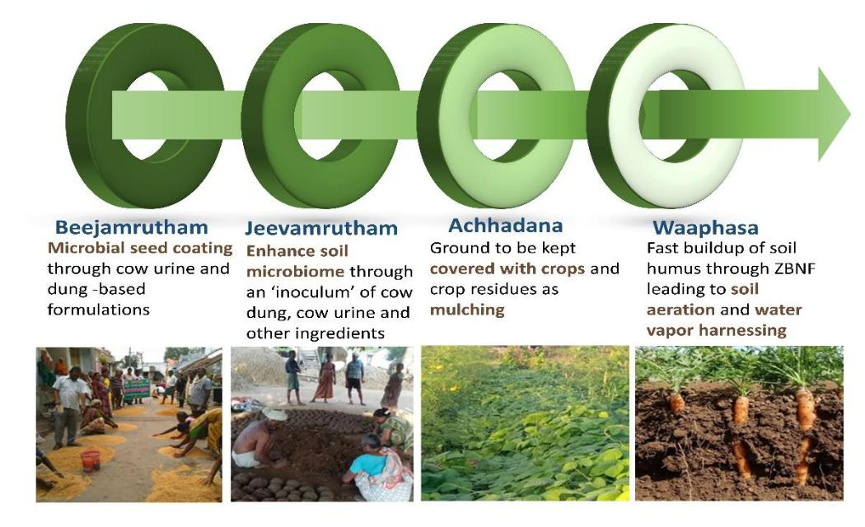

Along with adhering to zero-chemical usage, ZBNF follows certain other important principles:

- Use of ‘indigenous’ cow – for cow-dung and urine. According to Sh. Palekar, one cow is enough for cultivation of 30 acres – since cow dung is not a bio fertilizer. It is used as an inoculum.

- Botanical extracts prepared locally using local inputs such as neem leaves for pest management
- Indigenous seeds are critical for Z.B.N.F
- Minimal tillage is an important practice in ZBNF to avoid damaging the soil structure.
- All inputs to be made within the village

The ingredients used in preparing the inputs are locally available and locally prepared by farmers. They include – cow dung, cow urine, jaggery, uncontaminated soil, pulse flour, lime and water. Additionally, botanical extracts (from neem and other leaves, ginger, garlic, chilli, curd etc) are used to prepare decoctions to prevent any pests during the cultivation.
All these practices put together increases the humus content in the soil that fuels the vast number of organisms above and below the soil. This entire soil food web is what enhances the agriculture productivity, biodiversity, carbon sequestration and water availability.
3. APZBNF Model: Theory of Change
Zero-Budget Natural Farming (ZBNF), as a regenerative agriculture, is redefining the food and agriculture systems in Andhra Pradesh and addressing the core reasons of farmers’ distress
which is characterized by high-cost chemical farming that has resulted in losses and high debts for farmers, soil degradation, biodiversity loss, and water scarcity.
While ZBNF is a remarkable technology with a potential to address farmer distress, taking it to farmers and ensuring that farmers adopt this technology is the most challenging task. Farmers face barriers in adopting ZBNF if it is implemented on a piecemeal basis. Lack of knowledge, awareness and handholding support are key barriers to adoption. But more important are the obstacles from the entire ecosystem – right from family members, to neighbors, to other farmers in the village, and the village elders, sarpanches. The mainstream system of agriculture research, agriculture scientists, agriculture extension officers, fertilizer and pesticide dealers – all have been promoting chemical farming for over 30-50 years. It is on account of these obstacles that the adoption of an alternative agriculture paradigm has been so slow in the world. Till date there are only 0.5% certified organic farmers in the World.
Addressing these issues calls for a paradigm shift wherein a complete transformation of a village should be focused while trying to convert a single farmer.
In this context, Rythu Sadhikara Samstha under the aegis of Department of Agriculture have been firmly believing in three important theories of change in implementing ZBNF programme:

transformation should happen in a democratic way wherein women
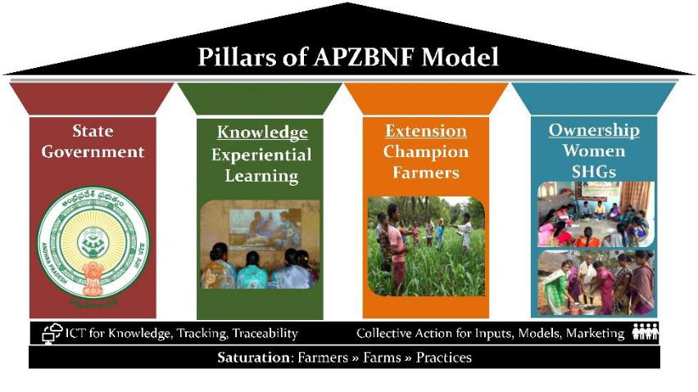

SHGs and farmer institutions are involved in programme planning, implementation and monitoring;

- Knowledge dissemination and handholding support is constantly provided through farmer-driven

extension architecture led by Community Resource Persons;
- Saturation of entire village, cluster, Mandal and the state (in that order) involves converting all villages, all farmers, all farms and all practices leading to a total transformation.

Essentially, these key pillars define the contours of the strategy, activities and the associated costs of implementation of APZBNF model.
Inspirational Trainings
The programme has been organizing mega training events delivered by Professions from the Department. So far, eight training events have been organized in our Vizianagaram District to about 1800 best-practicing farmers directly. These trainings add a huge impact on farmers in building their motivation and commitment levels to improve their own farming methods and also to take this programme to other farmers.
Benefits
ZBNF provides substantial economic benefits to farmers. Most important of them are:
- Reduced Cost
- Interest Savings
- Higher Yields
- Intercrop Value
- Fairer Returns
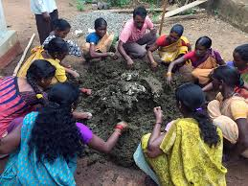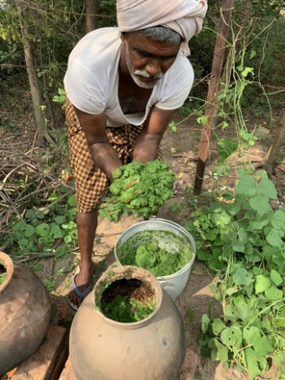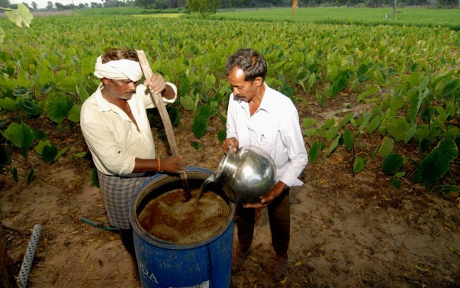
Ghana Jeevamrutham & Drava Jeevamrutham
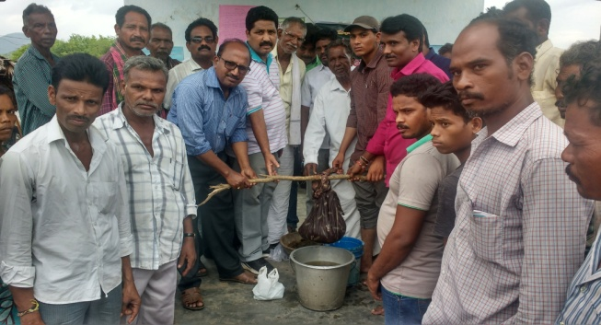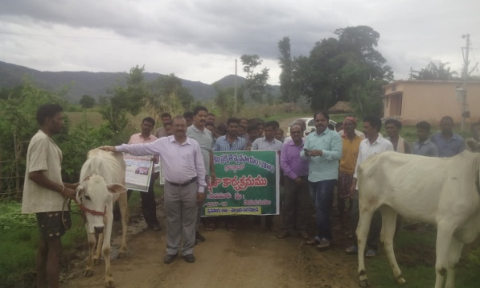
Mr.P.Venugopala Rao and resource persons were preparation of Ghana Jeevamrutham and Drava Jeevamrutham and Rally on ZBNF Activities.
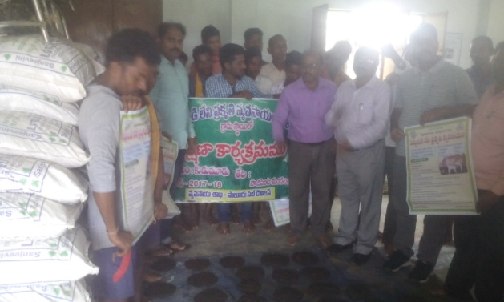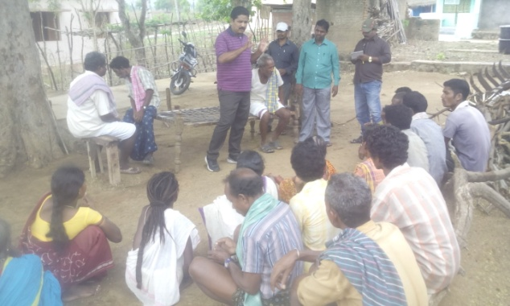
Mr.Venugopala Rao Explaining the benefits of ZBNF to Farmers
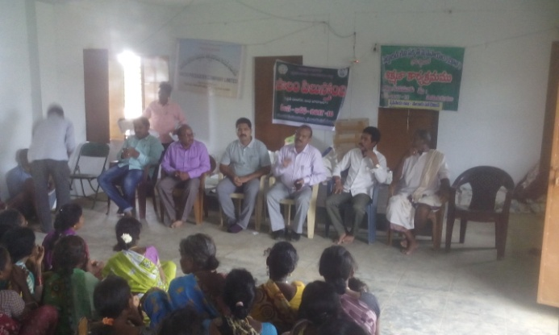
Meeting with Farmers on ZBNF Programmes activities.
CRECHE CENTERS

The ITDA, Parvatipuram has sanctioned the 19 Crèche Centers at Pachipenta, Salur and Makkuva Mandals. In the above 19 centers the following activities are going on.

Services provided in the Crèche Centers

- Daycare Facilities including Sleeping Facilities.
- Early Stimulation for children below 3 years and Pre-school Education for 3 to 6 years old children.
- Supplementary Nutrition (to be locally sourced)
- Growth Monitoring.
- Health Check-up and Immunization.

TARGET GROUP

The scheme focuses on children of 6 months to 6 years, of working women in rural and urban areas who are employed for a minimum period of 15 days in a month, or six months in a year.

NUMBER OF BENEFICIARIES AND FUNCTIONARIES

Ideally the number of children in the crèche should not be more than 25. Of these, at least 40 percent of children should, preferably, be below 3 years of age. It is important that adequate trained worker and helper are available to provide day care facilities and to supervise the functioning of the crèche. In addition to crèche worker, there should be one crèche helper looking after children.

PHYSICAL INFRASTRUCTURE
Location/Environment
The crèche located in a safe and secure place which is welcoming and child friendly. It is ideal to have the crèche near the homes of children or near the place of work of the mothers (at a walk able distance i.e. ½ - 1 km) for the following reasons: Mothers breastfeeding their babies can conveniently come to feed their babies.

• Parents can be contacted in case of emergencies
• It is easier to pickup, bring or send the child from home
• If a child is absent for a long period of time, the crèche worker can go herself to
• Enquire about the child from his/her home. As far as possible the crèche environment should be akin to the child’s home atmosphere and should also reflect the life style of the community.

Drinking water and Sanitary Facilities

The centre must have safe and regular drinking water facility. For this, centre should install a water filter/purifier which should be cleaned regularly. In places where there is shortage of water, adequate arrangements for storage of water may be done. At least one tank of 300 liters capacity may be installed. Child friendly toilets including for children with special needs should be available keeping in view the safety and security of children at the centre. A clean, Indian type child-friendly toilet with water facilities, soap, clean cloth/towel, garbage bin, wash basin/sink at low level and an exhaust fan should be part of the centre. The water tap should be placed at a height that can be used independently by children. The crèche should have a regular supply of cleaning material such as phenyl, disinfectants, rooms and swabs, dustbins, garbage bins etc. Regular supervision may be done for improving the services and maintaining hygienic conditions in crèche.
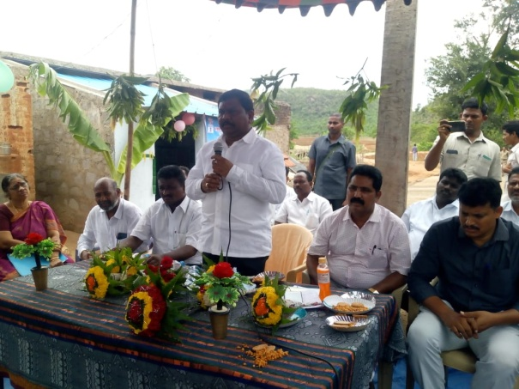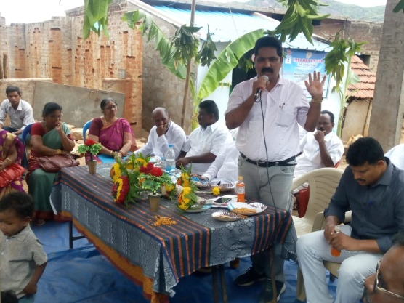
Sri.P.Rajanna dora, MLA, Circle Inspector and CDPO, ICDS inauguarates Creche Center at Bheemannadora Valasa, Pachipenta Mandal.
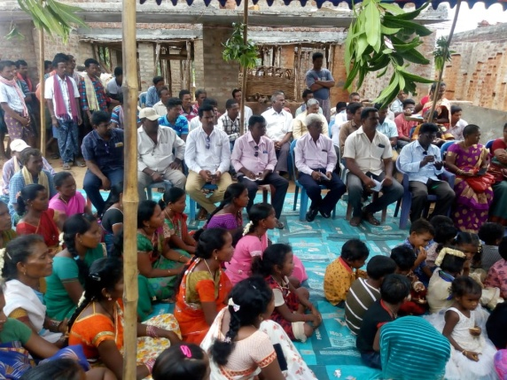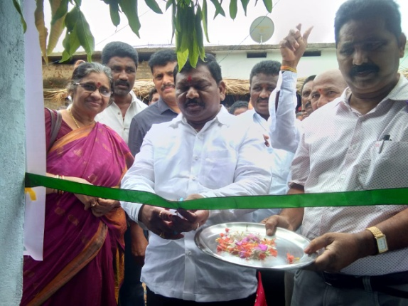

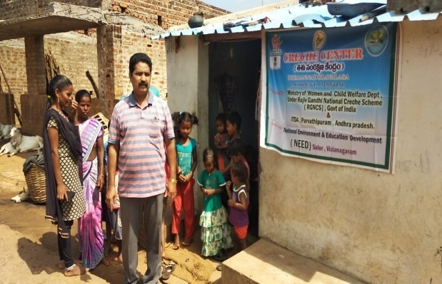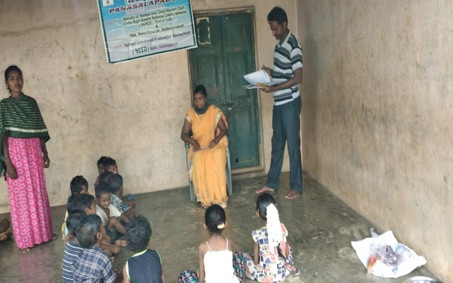
Mr.P.Venugopala Rao, Secretary of NEED visits Creche centers at Chaparai valasa and Neelamvalasa villages, Pachipenta Mandal.
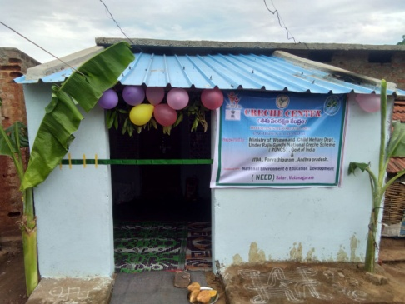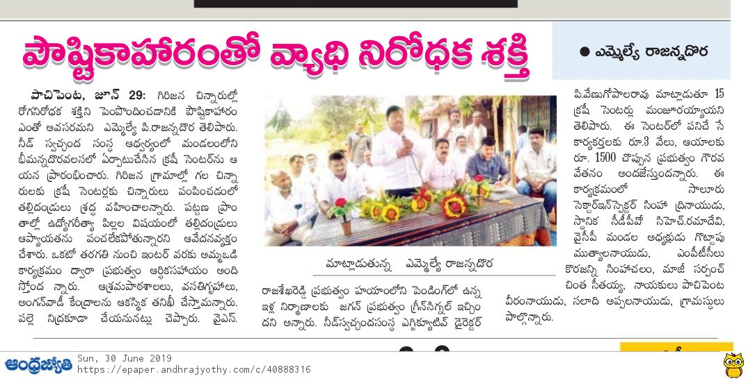
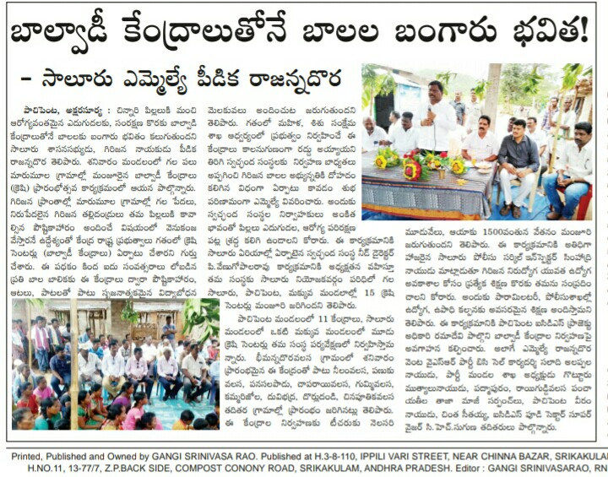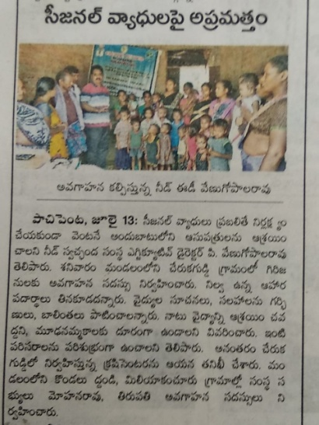

National Child Labour Project
The National Child Labour Project has kindly sanctioned the STC (Special Training Center) to our NEED organisation, we have implemented this STC programme in the following habitations with the support of Labour Department, Department of Municipal Administration and other line departments.

- Yeguva Sembi - 29 Children Enrolled
- Kunjimada - 28 children enrolled
- Diguva Sembi - 16 Children enrolled

Previously all the above children are working nearby Hotels, Lodges, Sanitation works, brick works etc., works at Mandal Headquarters. Through our NEED we have identified the above children and enrolled in STC Centers.

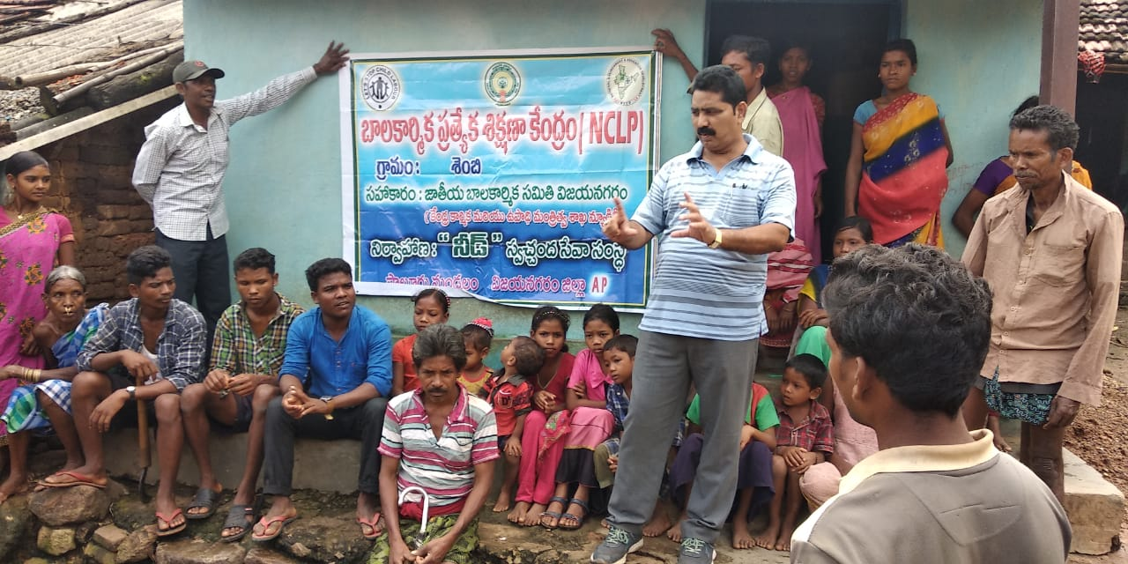
Mr.P.Venugopala Rao, Secretary of NEED explaining the Special Training Center concept to parents at Yeguva Sembi Village.
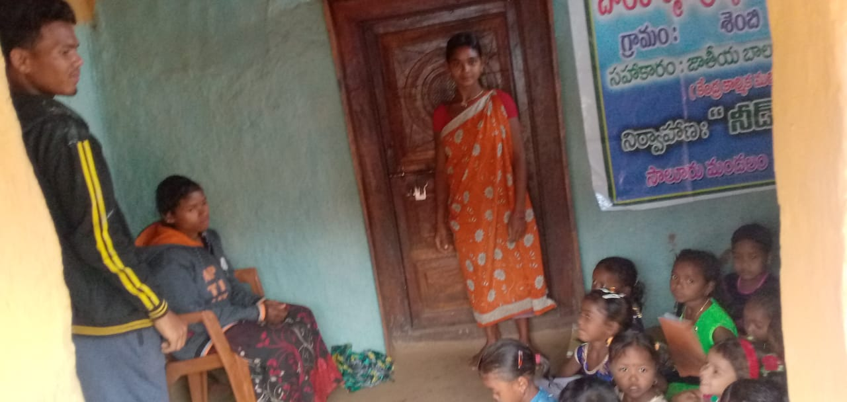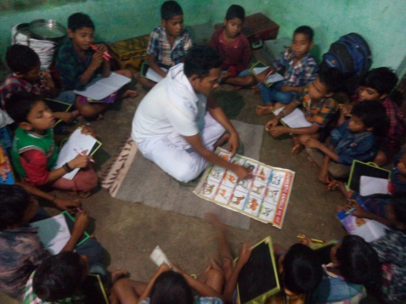
Classes organized by Teachers at Kunjimada and Diguva Sembi Villages.

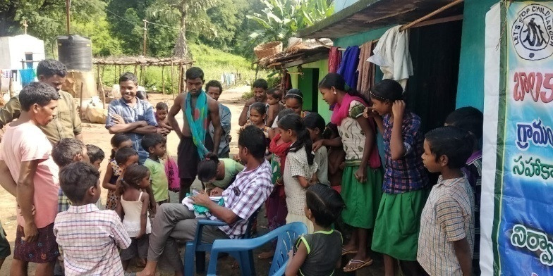
Block Level Sports Meet
Supported By : NEHRU YUVAKENDRA, VIZIANAGARAM
(Ministry of Youth Affairs & Sports, Government of India, New Delhi)

Brief Description about the Block Level Sports Meet:

Name of the Implementing Agency : National Environment & Education Development

Name of the Activity : Block Level Sports Meet
Venue : Degree College Grounds, Salur, Vizianagaram Dist.AP
Support Organisations : Local CBOs/NGOs etc.,
Date : 24th January, 2020
Supported By : Nehru Yuvakendra, Vizianagaram (A.P.)
Project Director (NEED) : Mr.P.Venugopala Rao
NYK District Coordinator : Mr.B.Vikram Aditya

Participated Guests : Programme Inaugurated by Sri.Lokeswara Rao,
Municipal commissioner, Salur and Sri.P. Suresh
babu, Principal and Sri.P.Nagabhushana Rao, Vice Principal, P.Konavalasa College and Sri.B.Vikram Aditya garu, District coordinator, NYK and Sri.P.Venugopala Rao, Executive Director, NEED.

Prizes Distributed Guests : Mr. K.V.Mahesh, Sub-Inspector, Salur Town
Mr. M. Tirupathi Rao, State Minimum Wages
Board member, A.P. Government.

Details of Sports : Volley Ball, Kabaddi, Running

Activities During the Programme : Pre Project Activities
Implementation of the Project
Post Project Activities

Facilities provided to participants : First aid kit, Lunch, Water, Travelling Charges etc.,

No. of Mandals youth Participated : Salur, Pachipenta and Makkuva Mandals

Total No. of Persons approached to Participation : Around 380 members

Total selected Candidates for this sports : around 324 members

Pre Project Activities:

The Nehru Yuva Kendra, Vizianagaram District Coordinator Mr. B.Vikrama Aditya has kindly sanctioned/allocated this Block Level sports meet programme to our National Environment & Education Development (NEED) organisation on dated 22nd January, 2020, then immediately Mr.P.Venugopala Rao and Programme Coordinator and Staff members were prepared a plan to implement this programme at Degree College Grounds, Salur, then immediately releases Press Note to all Press Reporters to our three mandals of Salur, Pachipenta and Makkuva. Based on the Press Note and oral communication and local leaders enthusiasm around 380 members are came from the three mandals for participation in the Block level sports, then immediately our Physical Director and our Staff were scrutinized the above candidates for the sports, as per our scrutiny around 324 candidates were selected for this block level sports meet.

Implementation of the Programme:

Our Project Director Mr. P.Venugopala Rao has instructed to every staff regarding the selected candidates separation for Team wise and sports wise through lottery system. As part of the separation of candidates they were prepared to play the games. We have organized the following games:

- Kabaddi (Boys and Girls)
- Volley Ball (Boys)
- Running (Boys and Girls)

S.NO | Name of the Game | Boys/Girls | No.of Teams | Total Players
1 | Vally ball | Boys | 21 | Total players 324
1 | Kabbadi | Boys | 12
2 | Kabbadi | Girls | 04
3 | Athletics (Running) | Boys | 18
4 | Athletics (Running) | Girls | 06
 | Total Teams |  | 61

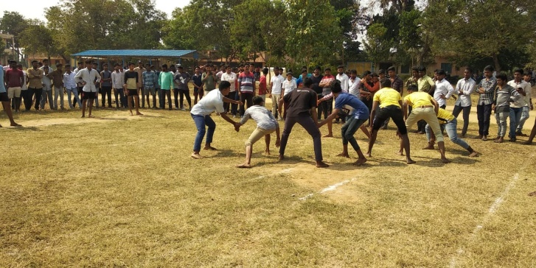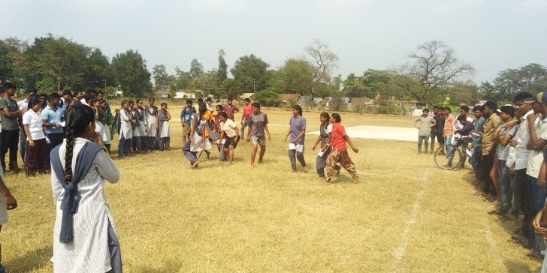

The following Candidates were selected as WINNERS

S.No | Name of the Game | Boys/Girls | Winner/ 1st Prize | Runner/2nd prize | 3rd Prize
 | Vally ball | Boys | B C Hostel,Salur | Kharusa valasa, Salur Mandal
 | Kabbadi | Boys | Kharusa valasa, Salur Mandal | Mathumuru, Pachipenta Mandal
 | Kabbadi | Girls | Tadangivalasa, Salur Mandal | Kottakki, Ramabhadrapuram Mandal
 | Athletics | Boys | K Venkatesh, Kurmarajupeta,Salur Mandal-1 st Prize | T Sai Kumar, P Konavalasa, Pachipenta Mandal, IInd Prize | G Sankara Rao, Siva Rampuram, Salur Mandal-IIIrd Prize
 | Athletics | Girls | B Radha, Vutapalli, Makkuva Mandal-Ist Prize | T Seerisha,Ramaswamy Valasa, Makkuva Mandal-IInd Prize | Venkata Lakshmi, Tasdangi Valasa, Salur Mandal-IIIrd Prize

Prizes Distribution :
Our Salur Sub-Inspector of Police Sri.Mahesh garu and NYK District Coordinator Mr.B.Vikrama Aditya garu and Mr.P.Venugopala Rao, NEED Executive Director garu has distributed the Prizes to Winners and Runners.

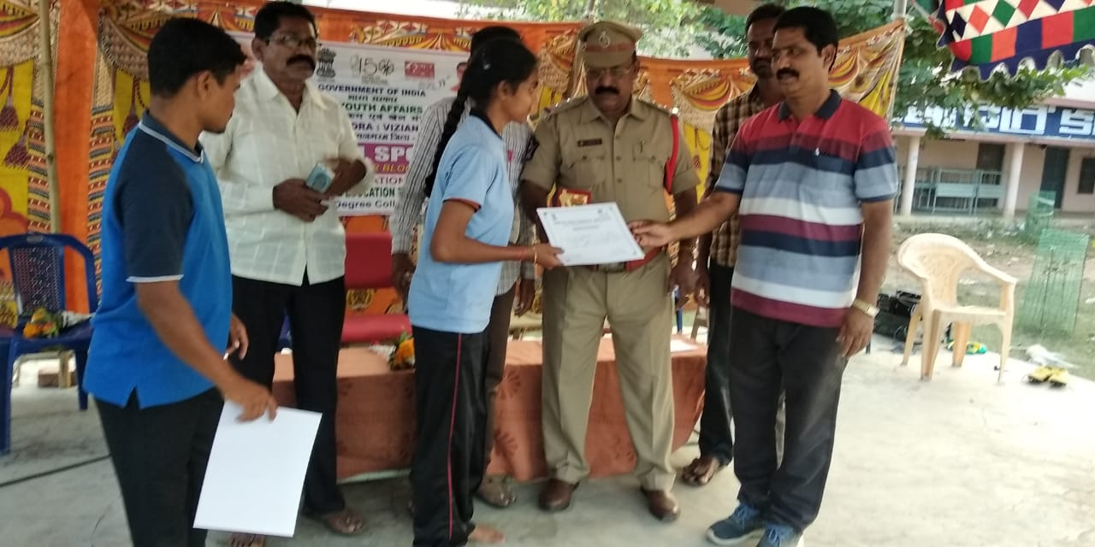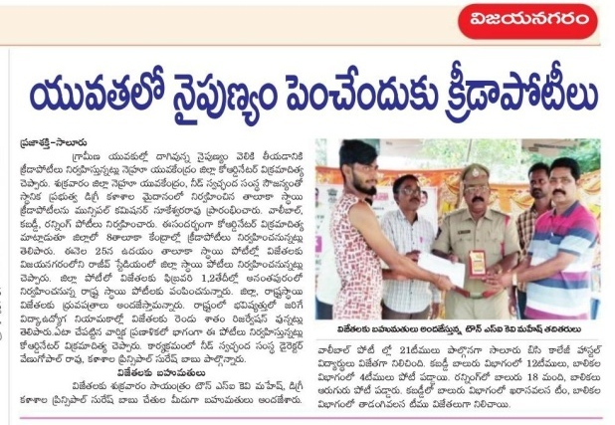

PRESS CLIPPINGS
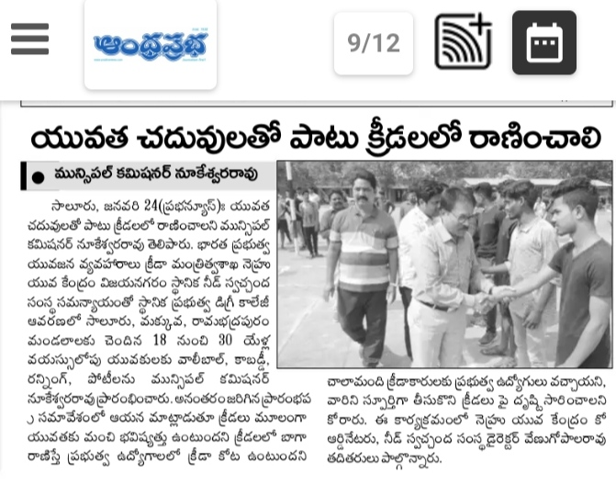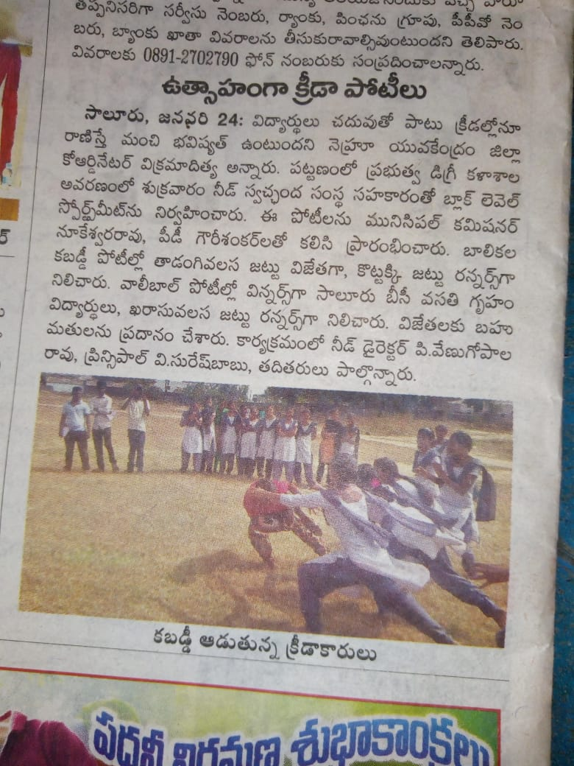
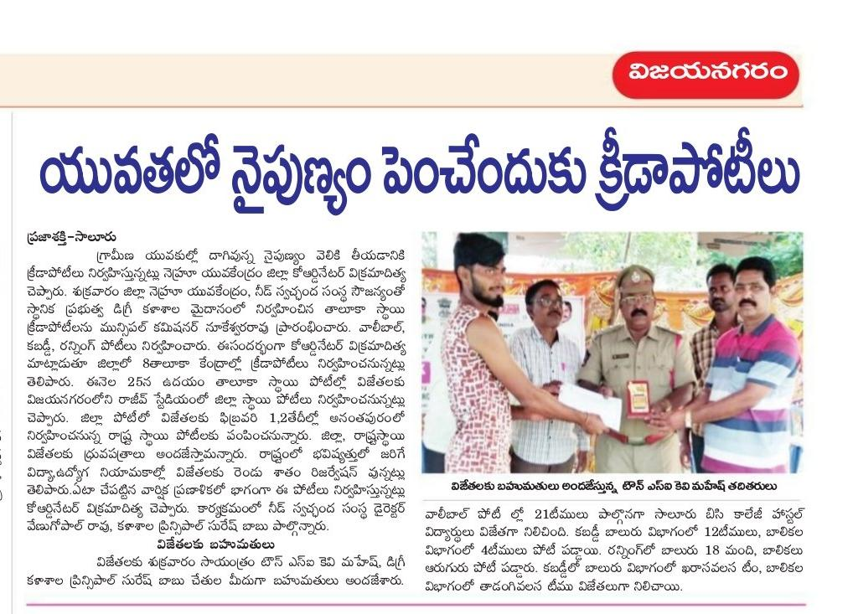
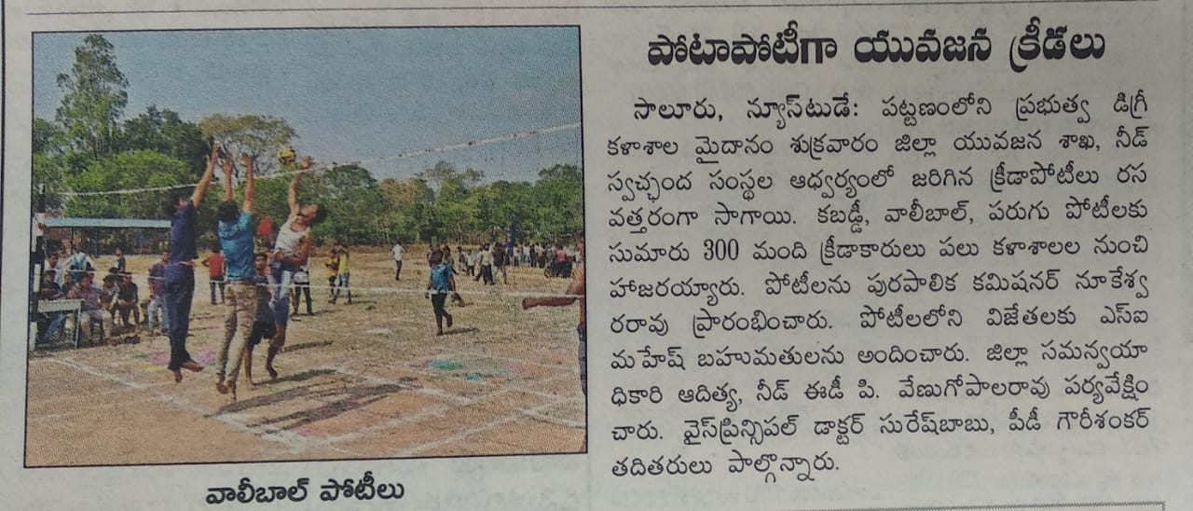

USHA SILAI SCHOOL PROJECT

USHA Sewing Schools across the country to help you learn and create. Courses in these schools range from one month to a year. USHA experts will teach you techniques and designs for custom clothing and creative stitching. In our Sewing School learn to design, cut, stitch, recycle, up cycle, embellish and hone your creativity to the next level.

The USHA has sanctioned the Silai School Project to our NEED organisation for unemployed youth especially women. Through these programme we have provided qualitative training to rural and urban poor women, and link up with Banks and other financial institutions for establishing the own tailoring units at their villages or streets.
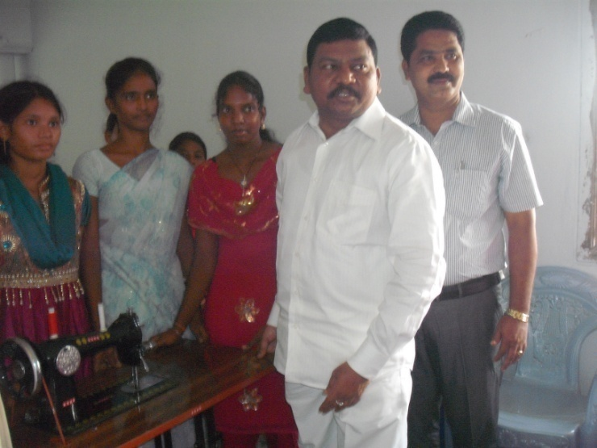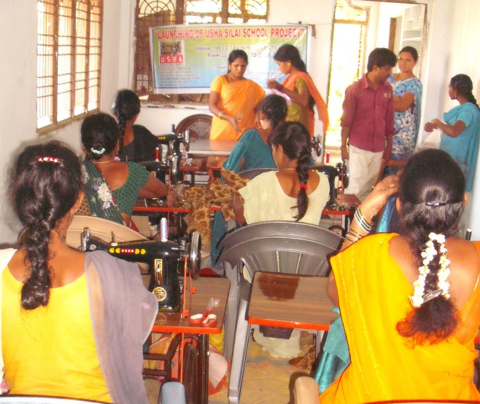

Sri.P.Rajanna Dora, M.L.A., garu has inaugurated the USHA Silai School programme at NEED Training Center, Salur.

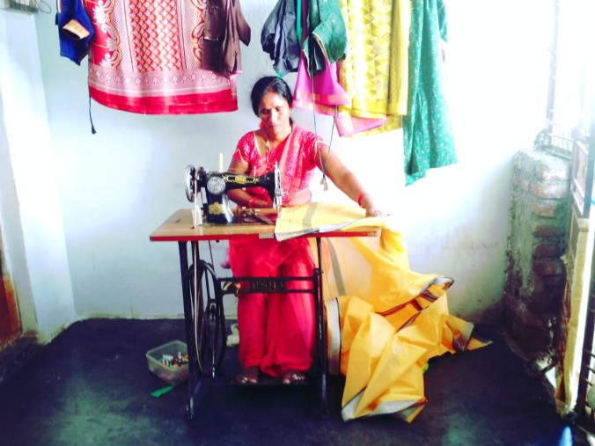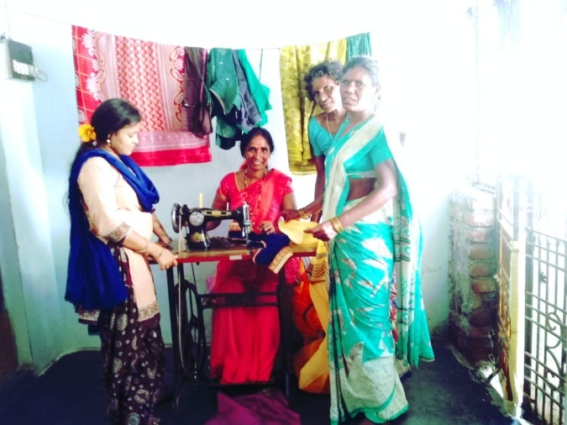

Smt.Anuradha, Trainee has practicing self employment general at their home.

COVID – 19
RELIEF ACTIVITIES.

In response to the rising severity and impact of the coronavirus outbreak, NEED organisation has initiated impactful activities aimed at providing safety and relief to individuals and communities.
NEED is collaborating with the Government to prepare and distribute nutritious meals to all front line professionals covering doctors, nurses, government officials, policemen, etc. who are relentlessly serving the nation to combat this crisis.
Additionally, Ration kits will be distributed to daily wage earners, who are unable to sustain normal life on account of the current situation.
Health Safety equipment and supplies will be distributed to medical and paramedical professionals in nominated hospitals to ensure their safety and to prevent further transmission of infections.
The Animal Care team will also provide food to stray animals during this crisis.
During these times, we pray for the safety and recovery of all, and may we undertake all precautions necessary to ensure the health and well-being of ourselves and our loved ones.
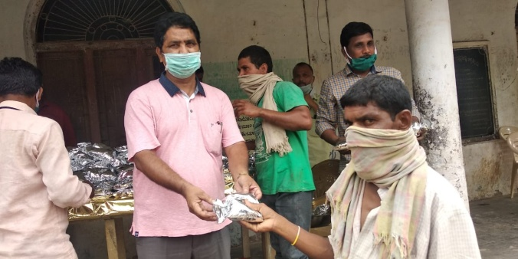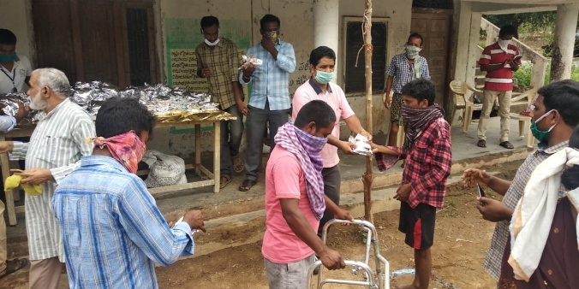

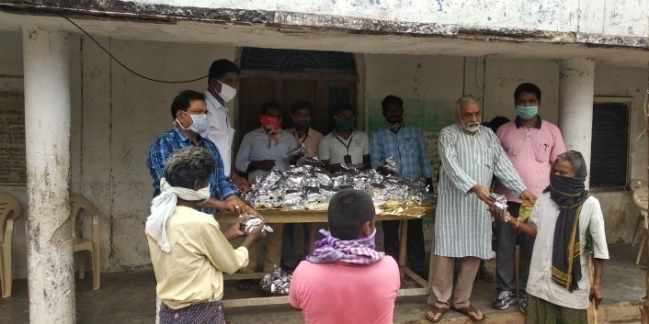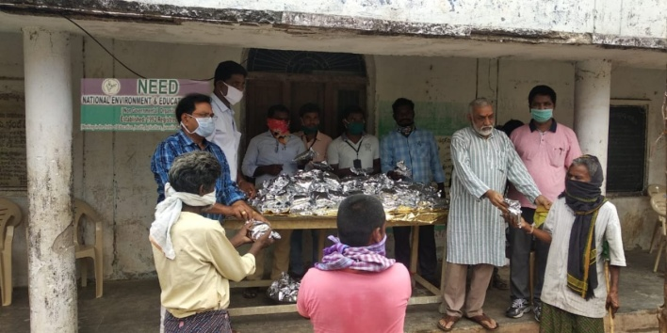
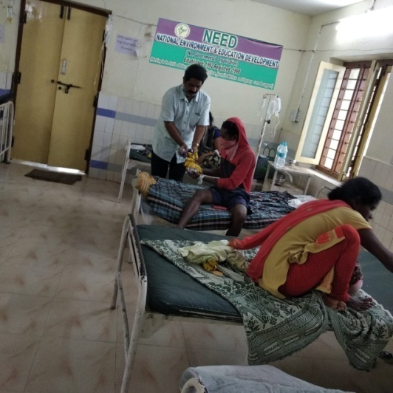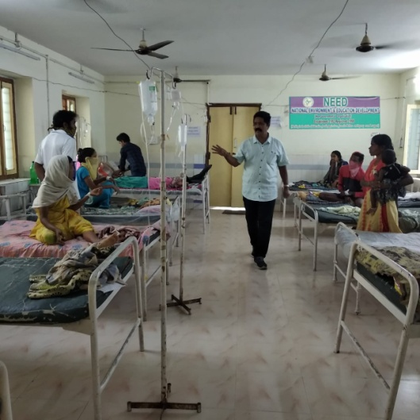

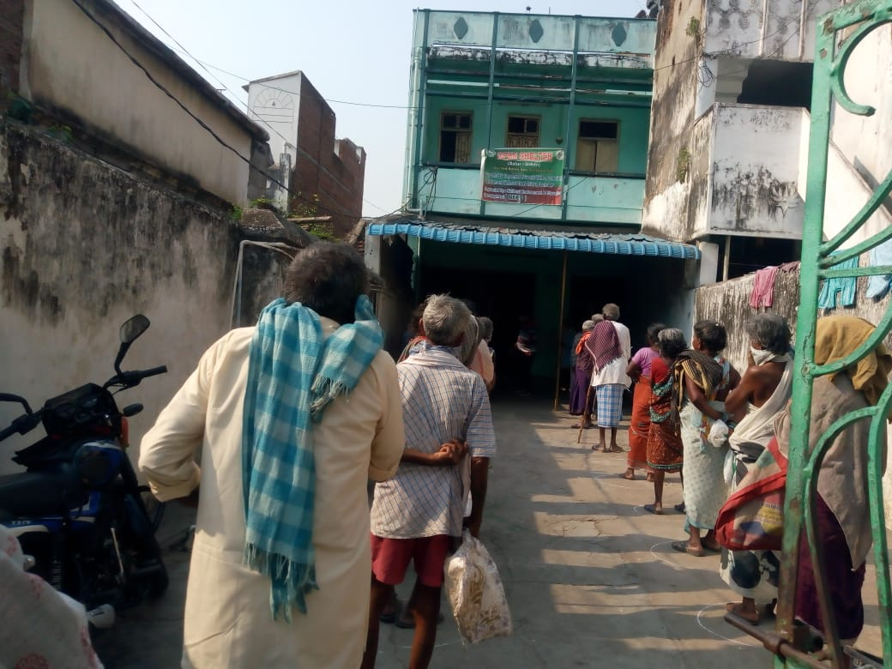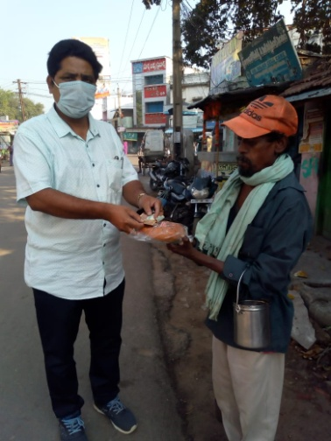

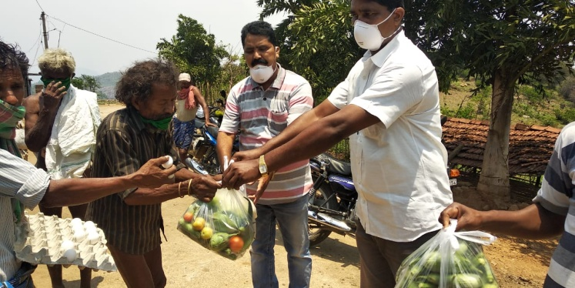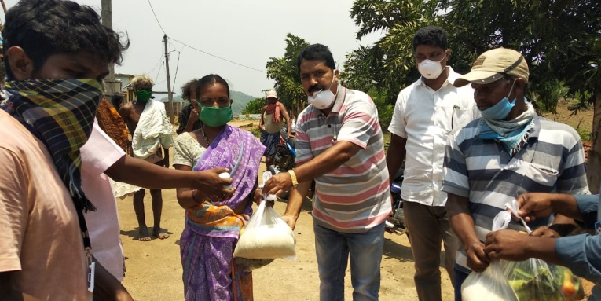

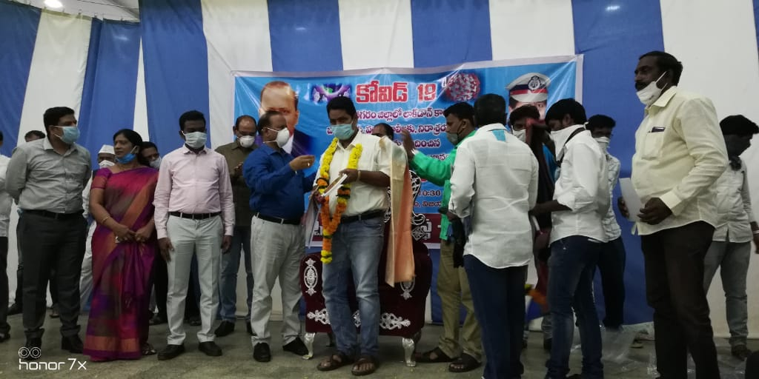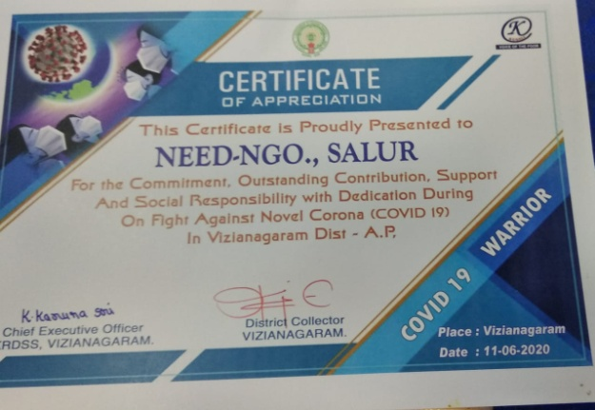
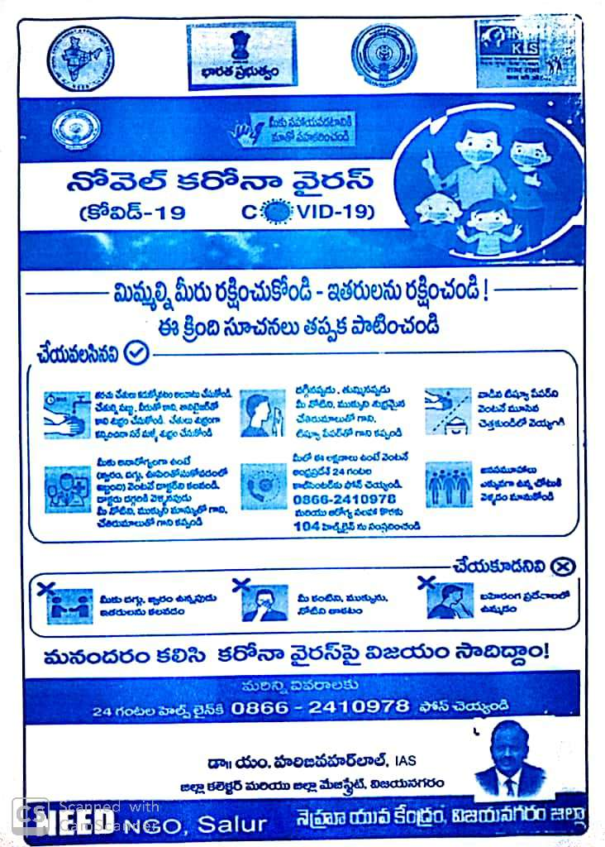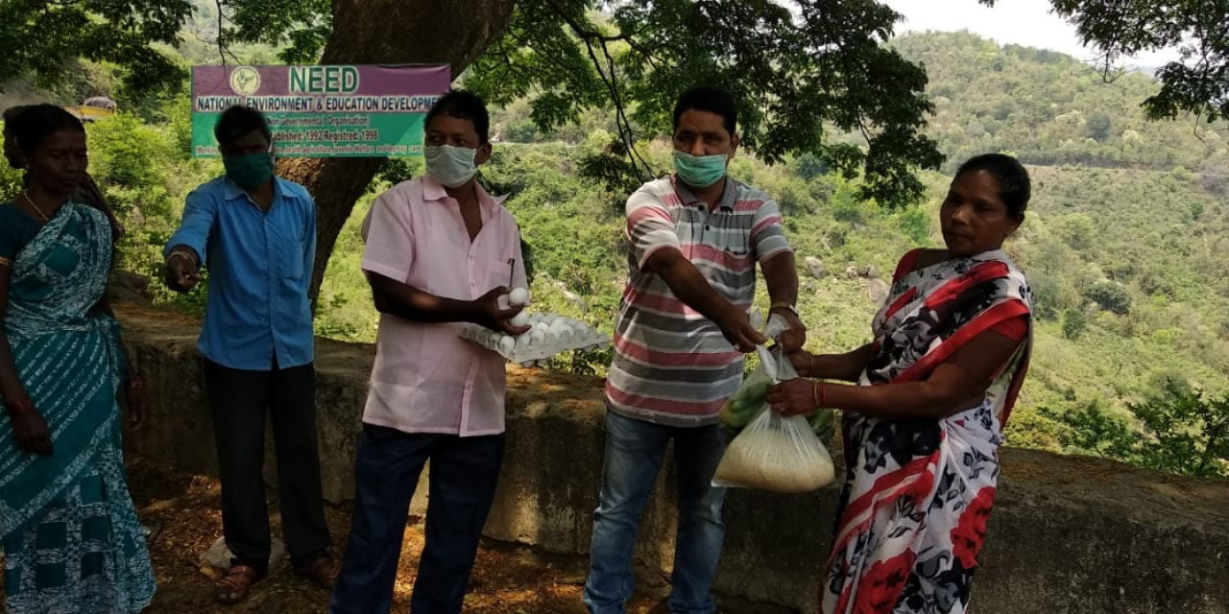

TERRA DES HOMMES
Helping Children World wide

The Terra Des homes has sanctioned the “Children on the Move- Destination Unknown” awareness Programme to our NEED organisation, this programme was conducted in the year of 2018-2019.

RALLY IN SALUR

Big Rally was organized in the Town of SALUR with 100 memebers started from NEED office covering RTC Bus Station, MRO office, Bosu Bomma, Sivaji Centers by slogans, Play Cards showing and crowding about importance of education, Education is more than work, Save Child Rights Save RTE Act and avoid Child labour.After compleation of rally Mr P Venugopala RAO, Executive Director explained about the ongoing programmes, Which are continually organizing by NEED such as Education, Disability, Open Shelter, Health, Urban Residential Hostels (URH) etc. He warned nobody should involve the students in work places and used them as child labours. He also explained about the role of CWC, JJB,DCPU,Child Line which are only working for the welfare of children and their rights.

RALLY IN BOBBILIVALASA PACHIPENTA MANDAL

Big Rally is conducted at Bibbilivalasa village in Pachipenta Mandal with 80 members who are Samatha Coordinator Mr Satish, NEED Organisation Secretary P Venugopala Rao, NEED Staff, village elders ,MPTC,Surpanch,School Head master,Teachers , SHG Grops,Local Community and Children. Slowaganns and Play cards showed in the Rally about RTE Act, Child Rights etc.
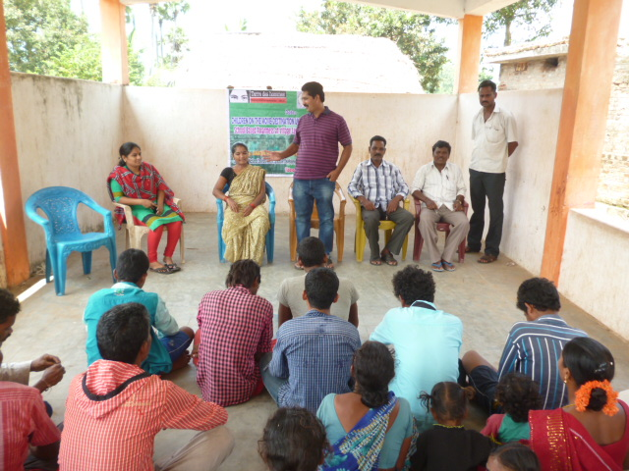
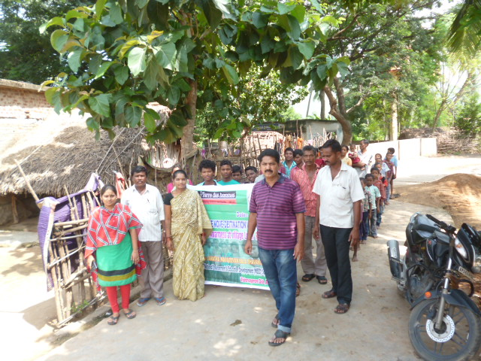

GENERAL ACTIVITIES

General Programmes:
Health Awareness Programmes:
In the year of 2019-2020 we have organized health awareness programmes in Pachipenta, Salur and Makkuva mandals of our Vizianagaram district, those programmes was organized with the support of local donors and local elders.
Sanitation Awareness Programmes:
We have conducted sanitation awareness programmes in Salur urban and Pachipenta rural areas, especially we have explains dry waste and wet waste segregation, home composting, drainages cleaning, sanitation activities etc.,
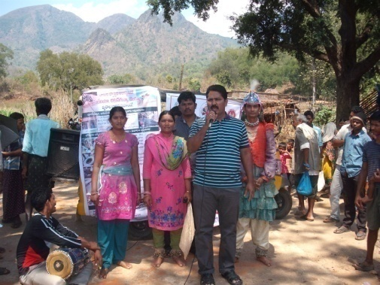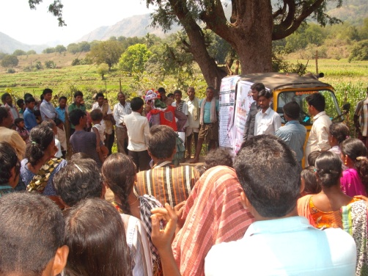
VSS trainings:
We have conducted VSS Training programmes & rallies on plantation in our Pachipenta and Salur Mandals (salur range), in this programmes we have explained to VSS members on their roles and responsibilities, NTFP, records maintenance etc.,
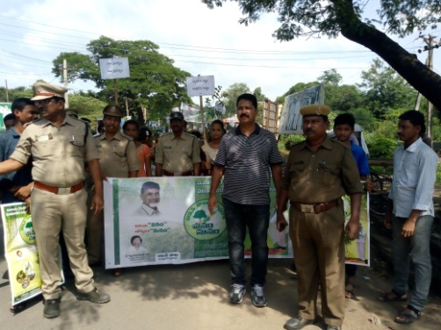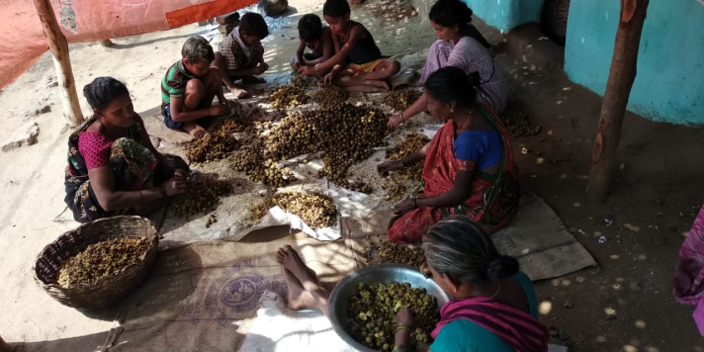

(P.VENUGOPALA RAO)
Secretary/Executive Director
NEED.

